CoDR Report Draft

Jäger-QRF: Fire Fighter Drone

Presented To:
University of California, San Diego
Department of Mechanical and Aerospace Engineering

MAE 155A
Professor John T. Hwang

Prepared By:
Group 1: Harshil Patel, John Sigafoos, Angel Ochoa, Juan Sanchez, Sara Chowdhury, and Analisa Veloz

1. Executive Summary
Wildfires and structural fires can escalate rapidly during their early stages, often before firefighting crews arrive on scene. Early intervention during the initial phase can significantly reduce fire spread, property damage, and risk to emergency responders. Current aerial firefighting solutions, such as helicopters and airtankers, are typically not deployed until a fire has fully developed and often require significant mobilization time, trained flight crews, and high operational costs.
To address these limitations, the proposed unmanned aerial vehicle (UAV) must satisfy specific mission requirements to support rapid aerial firefighting operations. The UAV will operate at or below the Federal Aviation Administration (FAA) altitude limit of approximately 400 ft above ground level (AGL) and must be capable of reaching a fire scene before ground-based firefighting vehicles. To meet this requirement, the UAV will cruise at a minimum speed of 51.43 mph and deploy the first of two payloads within the first 180 seconds of takeoff. Upon arrival at the fire scene, the UAV will identify the target area, maneuver to the appropriate release position, and activate the payload deployment mechanism. Each payload will be capable of suppressing a fire within a three-meter radius. Following payload deployment, the UAV will safely return to the launch station without sustaining structural or functional damage.
The UAV employs a quadcopter VTOL configuration integrated with a fixed-wing airframe and tilt-rotor system. This configuration enables vertical takeoff, landing, and sustained hover for payload deployment without requiring a runway, allowing rapid launch from firefighter stations. During VTOL operations, all rotors provide lift, while in forward flight, the two aft rotors tilt to generate thrust, and the fixed wing supplies most of the lift, significantly reducing power demand compared with hover. Aircraft control in cruise is primarily achieved through conventional control surfaces, including ailerons and a ruddervator, which provide combined elevator and rudder authority. The fuselage houses avionics, two fire-extinguisher payloads with deployment mechanisms, and a forward-mounted FLIR camera for thermal imaging.
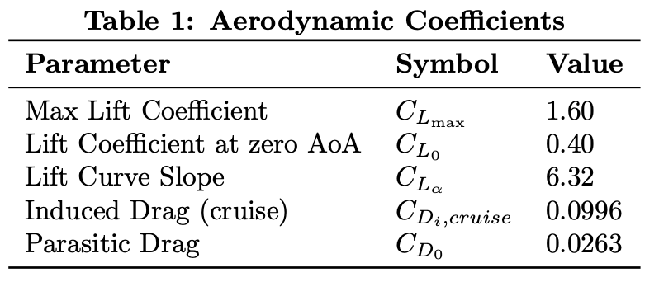
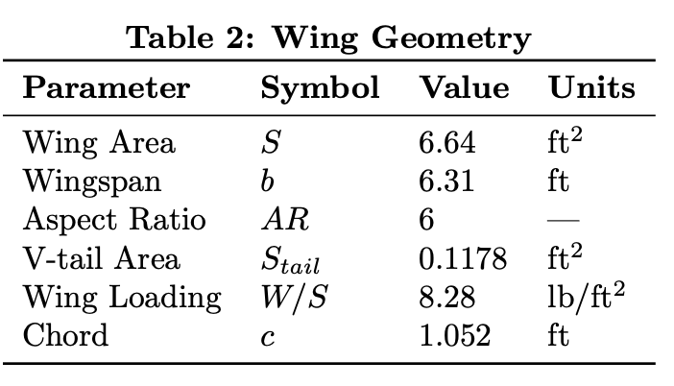
1.1 Aircraft Specifications
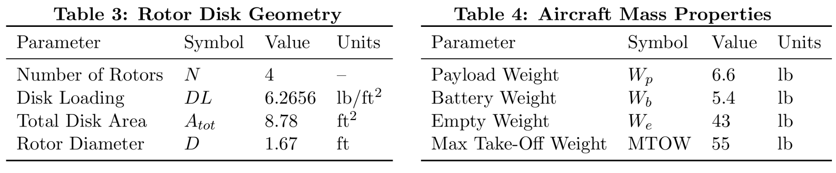
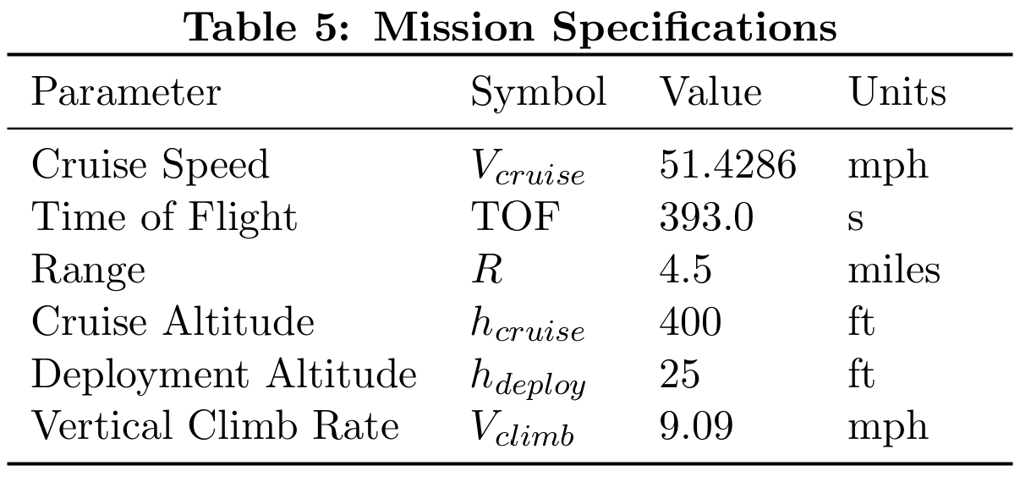
1.2 Technical Drawing
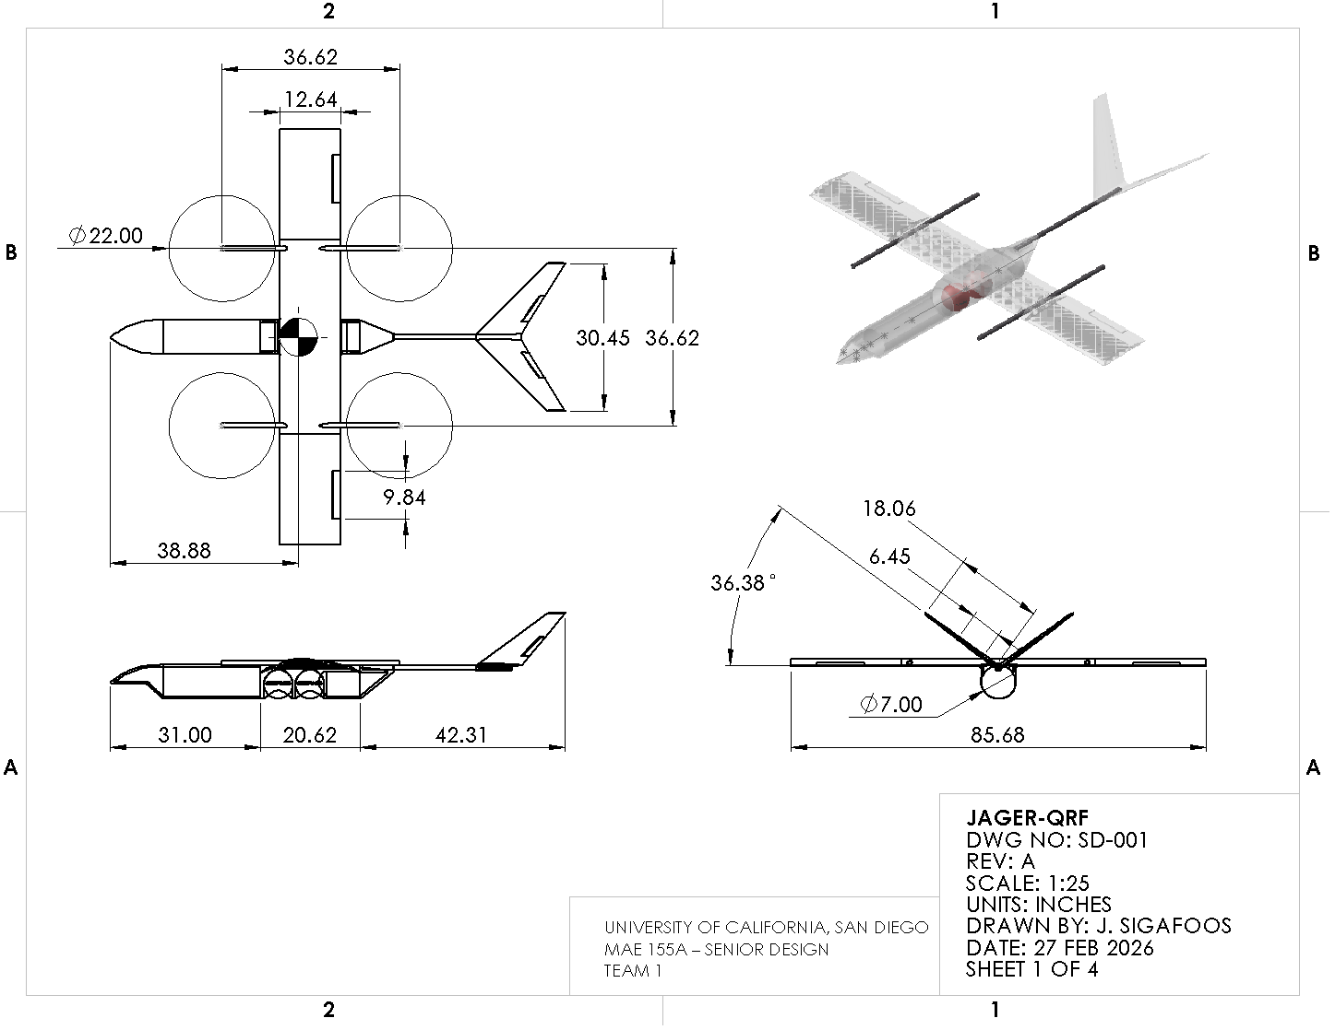

Figure 1: Technical Drawing
2. Introduction
In today's era, wildfires and structural fires pose rapidly evolving, high-risk environments in which limited visibility, uncertain access routes, and time-critical decision-making significantly endanger first responders ^{[2]}. In today’s technological world, small unmanned aerial systems (sUAS) have enabled aerial reconnaissance and thermal imaging support for emergency response; however, conventional multirotor platforms are constrained by limited range and endurance, while fixed-wing UAVs lack vertical takeoff, landing, and hover capabilities required for precise operations ^{[3]}. Hybrid VTOL configurations show promise by combining the endurance and cruise efficiency of fixed-wing aircraft.
This project addresses the design of a rapid-response firefighting support UAV capable of operating within FAA small UAS constraints while providing real-time aerial visibility and localized fire-suppression capability ^{[4]}. The primary objective of this drone is to achieve sufficient cruise speed to arrive at the target area ahead of ground vehicles, transition to stable hover for payload deployment, and safely return to base while maintaining structural and operational integrity. Furthermore, these key enabling technologies include electric VTOL propulsion, lightweight composite structures, high-energy-density batteries, and thermal imaging sensors. The analysis evaluates system performance using metrics such as cruise speed, stall speed, response time, payload fraction, hover endurance, and mass efficiency.

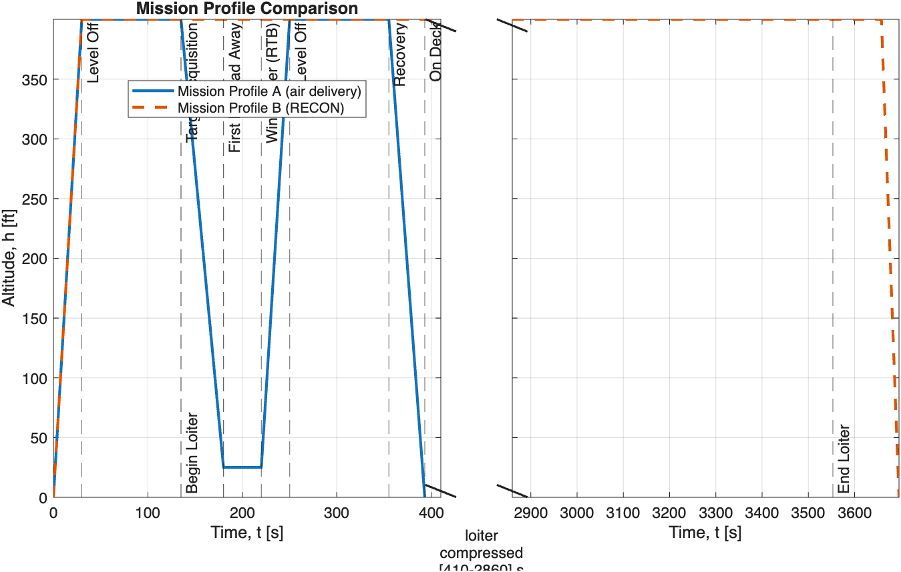
Figure 2: Mission profile where the blue line denotes Mission A, and Red for mission B, represents the change in altitude over time

3. Concept of Operations
Jäger-QRF is autonomously deployed from a local fire station in VTOL mode, climbing vertically at a constant climb rate V_{Climb,} , to the cruise altitude h_{Cruise}​. After reaching altitude, Jäger transitions to forward flight and maintains cruise speed V_{Cruise}​, during outbound transit to the target area (Figure 2).
For Mission Profile A (air delivery), Jäger enters a target acquisition phase upon arrival, using its FLIR turret and onboard sensors to identify the optimal drop location. The aircraft then descends to the deployment altitude and performs the first payload release at 180 s after takeoff. Because excess power remains available, Jäger can extend the hover period by an additional 45 s and execute a second payload deployment. After payload release, Jäger enters Winchester state and returns to base at V_{Cruise}​ and h_{Cruise}​.
For Mission Profile B (reconnaissance/loiter), the payload mass and volume are replaced with an equivalently sized third battery pack. This configuration enables Jäger-QRF to provide persistent aerial surveillance over the incident area using the FLIR turret and onboard camera suite. The takeoff, climb, outbound transit, return-to-base, and landing segments are unchanged from Mission Profile A. However, instead of descending for payload delivery, the aircraft remains at cruise altitude and enters a reduced-speed loiter orbit over the target area. In this configuration, Jäger achieves a loiter speed of 41.14 mph and a recon endurance of 3418 s (57.0 min), yielding a total mission time of 3696 s (61.6 min). This mission allows Jäger to provide real-time thermal and visual reconnaissance, support search-and-rescue operations, and supply on-scene situational awareness to emergency responders.
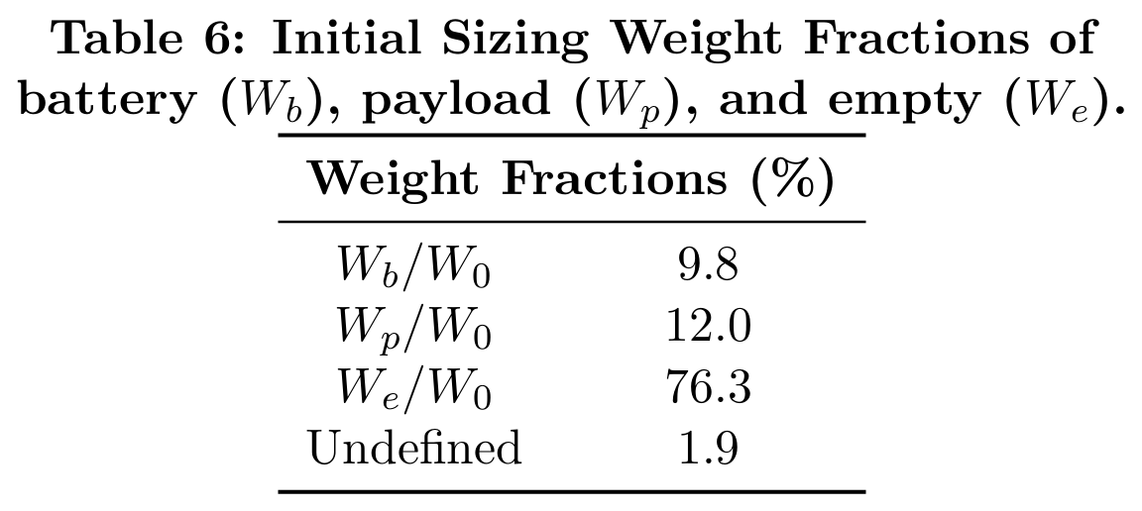
In both Profile A and B, Jager-QRF upon final approach to the fire station, transitions back to VTOL flight and descends to a precise landing on ground support equipment, where a single operator can rearm and recharge the vehicle, enabling safe recovery in rural, suburban or urban settings.

4. Initial Sizing
The mission requirements and payload constraints place the aircraft in the 55-lb class of urban air mobility (UAM) delivery platforms. The design process begins by estimating the power requirements for cruise, hover, and hover-climb flight conditions. The analysis uses battery energy densities and baseline electrical efficiencies to estimate the battery mass fraction (Table 6). Constraint equation analysis produces power-loading and wing-loading constraint curves that define the design region (Figure 3). The climb power requirement and stall speed constraint dominate the design space.
5. Concept
The concept evolved alongside the initial sizing and mission planning process. Existing package-delivery UAVs provided an outline to the proposed mission profile.^{[8]} Due to the mission's precise payload deployment requirements, the design must achieve hover performance comparable to that of delivery drones. This requirement led to the selection of a quadcopter configuration with four rotors. Because the drone is designed to be deployed and recovered directly from GSE, as described in Section 3, the configuration does not require a conventional landing gear, which reduces structural weight and aerodynamic drag.
To improve mission performance, the design incorporates a hybrid VTOL and fixed-wing cruise configuration, enabling efficient forward flight while maintaining vertical takeoff and hovering capability. The wing generates the majority of lift during cruise, reducing the power required from the rotors and improving overall energy efficiency. This approach increases the aircraft's range and allows it to carry a larger payload. The rotor configuration contributes to the vehicle’s weight and efficiency. During cruise flight, the two forward rotors shut down while the two aft rotors operate as pusher propellers. This configuration reduces power consumption during cruise while maintaining strong hover performance.
The fuselage design prioritizes aerodynamic efficiency and internal payload accommodation. A tubular fuselage design minimizes drag while maintaining structural simplicity. The initial fuselage length roughly matches the wingspan, providing sufficient space for avionics, payload storage, and battery placement. A recessed “chin” section beneath the nose houses the FLIR turret and provides an unobstructed field of view for thermal imaging.
The tail configuration contributes to the aircraft’s stability and aerodynamic efficiency. The design uses a V-tail configuration to reduce weight and minimize drag while maintaining adequate control authority. The dihedral geometry of the V-tail generates restoring moments that improve roll stability during cruise flight.^{[3]} Additionally, the V-tail placement keeps the control surfaces clear of propeller wake from the pusher rotors, improving aerodynamic efficiency and control effectiveness.
6. Aerodynamics
The aerodynamic analysis models aircraft performance using a quadratic drag polar and a lift-curve relationship (Table 1). The analysis uses a semi-empirical formulation to evaluate the lift coefficient as a function of angle of attack (Figure 4) and assumes inviscid flow under the low-Reynolds-number flight conditions expected for this aircraft. Under this assumption, steady level flight requires lift to balance weight, yielding a maximum lift coefficient of C_{L, max} = 1.23
The drag polar indicates a maximum lift-to-drag ratio of 10.1 at an approximate $C_{D}$ value of 0.075, corresponding to optimal cruise conditions. The total drag coefficient is expressed as the sum of parasitic drag and induced drag. A parasitic drag coefficient of 0.037, consistent with values reported for similar configurations. The Oswald efficiency factor is estimated to be 0.8.
The design prioritizes an airfoil that provides positive lift at low angles of attack while maintaining strong aerodynamic efficiency. The NACA 4412 airfoil offers favorable lift characteristics and lift-to-drag performance for a low-Reynolds-number flight.

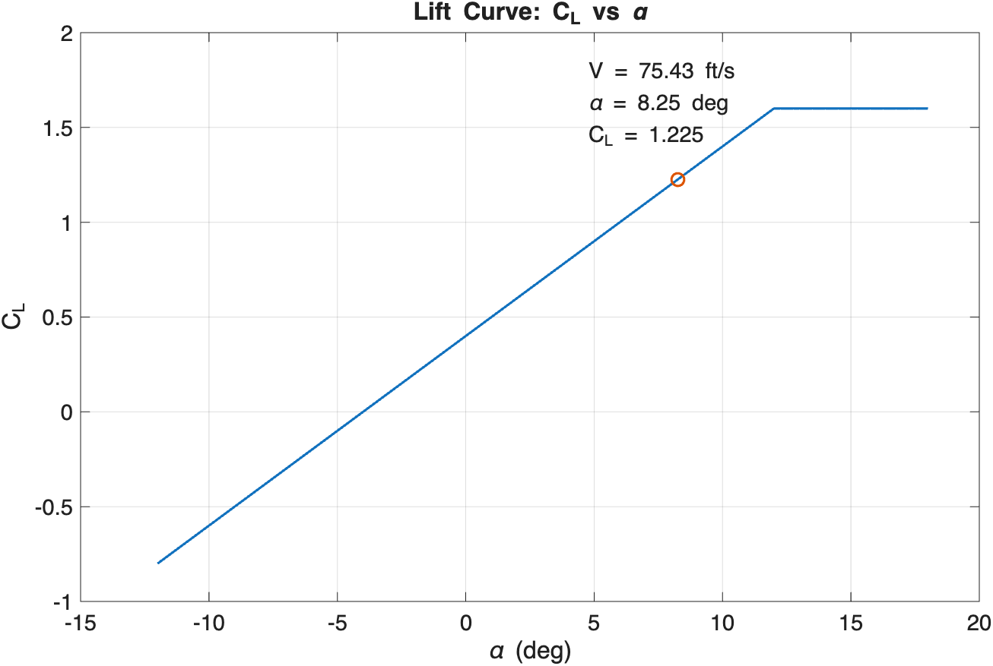  Figure 4: Lift Coefficient (C_{L}) versus Angle of Attack ($α)$ | 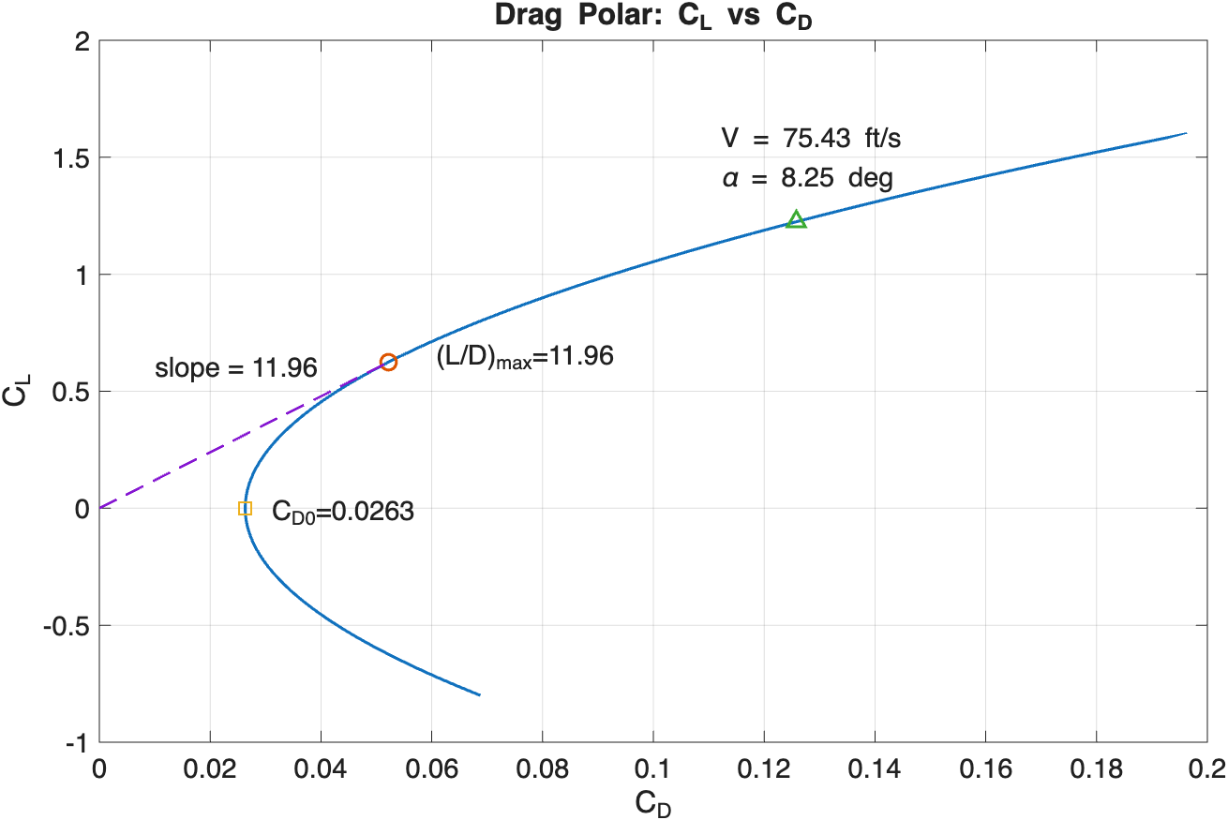  Figure 5: Drag Polar: Lift Coefficient (C_{L}) versus Drag Coefficient (C_{D})
7. Propulsion

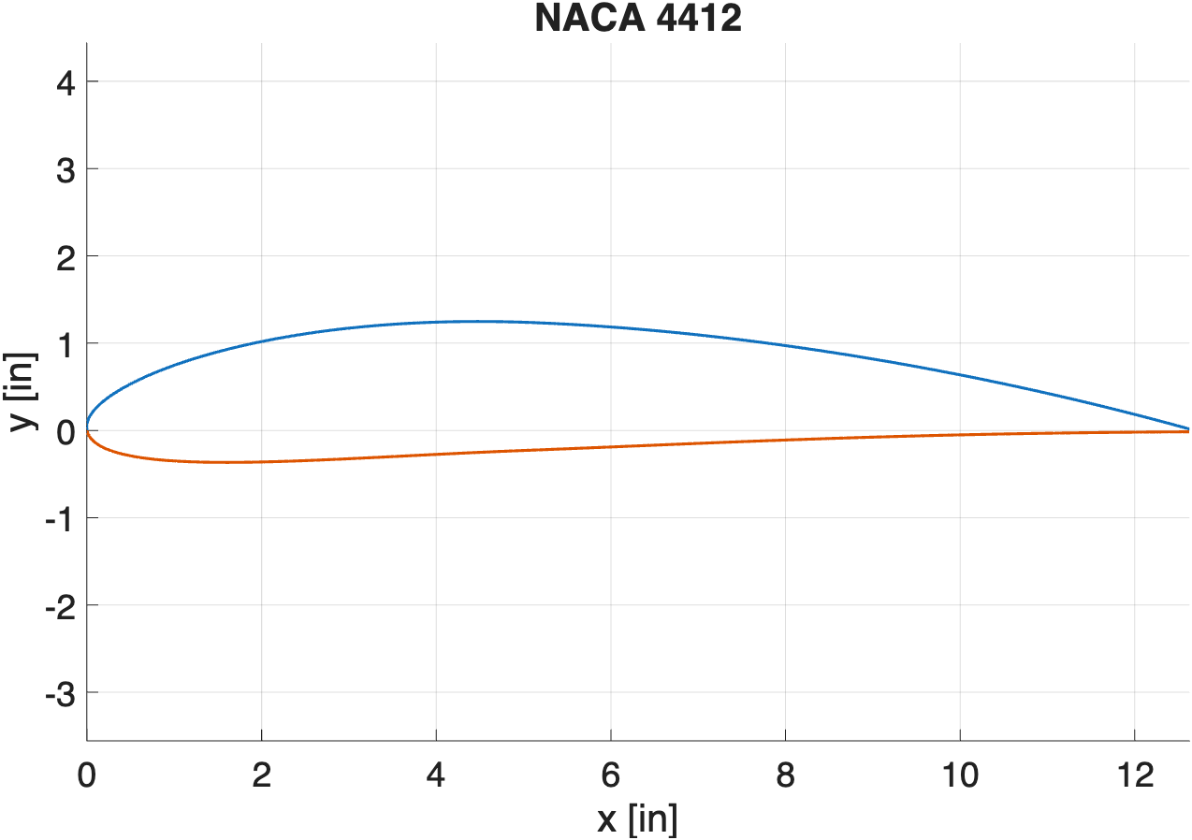  Figure 6: Plotted NACA 4412 cambered airfoil | 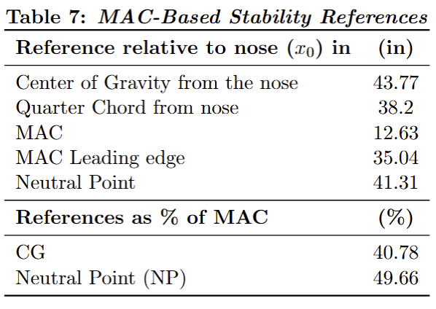
The design uses an electric propulsion system because UAVs in this weight class and comparable delivery drone platforms rely primarily on similar systems. ^{[3]} Electric propulsion reduces mechanical complexity, improves reliability, simplifies integration with existing firefighting infrastructure, and minimizes required maintenance.
The propulsion system design begins with battery selection. The calculated battery mass fraction, $\frac{W_{b}}{W_{0}}$, determines the required onboard energy storage. The design therefore uses two 10S lithium battery packs connected in parallel to satisfy the vehicle’s energy requirements (Figure 7, Table 7). Using two battery packs also improves weight and balance flexibility, allowing adjustment of component placement to control the aircraft's center of gravity.
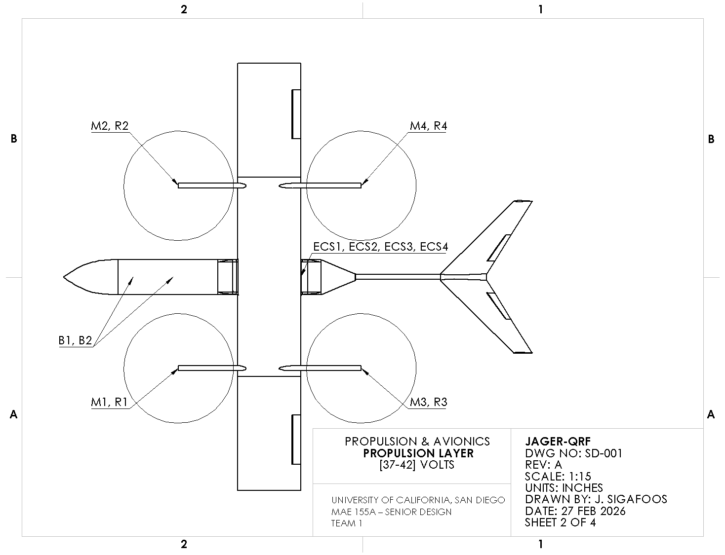  Figure 7: Propulsion Diagram | 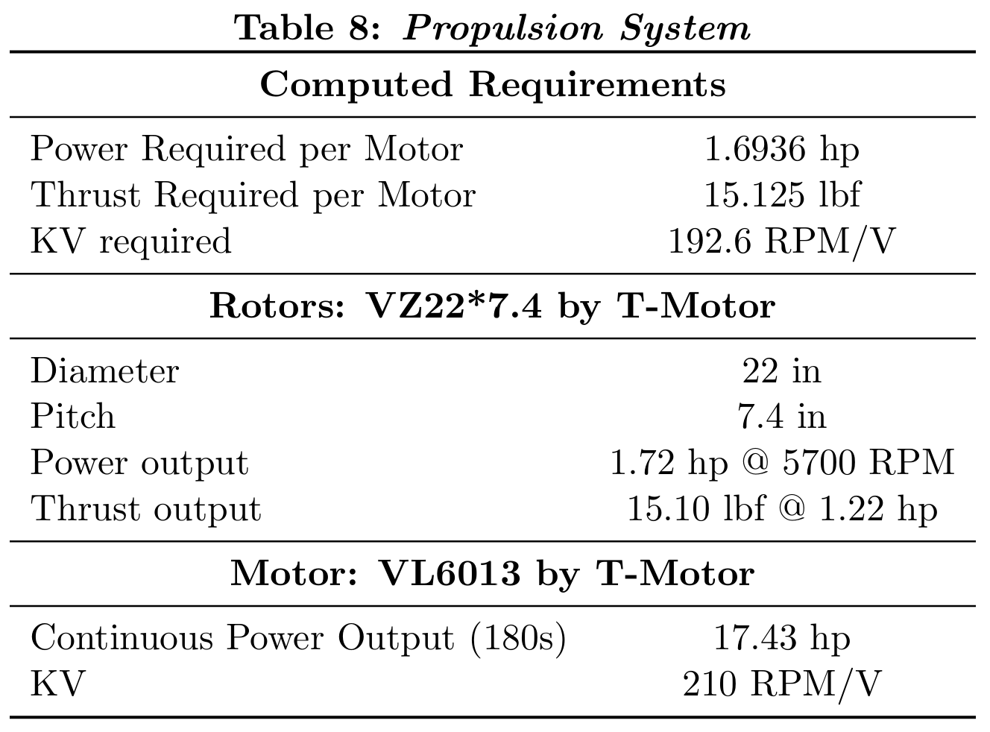

The sizing model then determines the required thrust per propeller, the target motor KV rating, and the maximum motor power output. The rotor sizing analysis produces a propeller radius of approximately 11 inches, satisfying the disk loading constraints and improving hover efficiency (Table 8). The propulsion system integrates electronic speed controllers (ESCs) that enforce voltage and current limits for the selected motors and battery configurations.
8. Weight and Balance
The analysis determines the aircraft center of gravity (CG) location and evaluates longitudinal static stability. The analysis assigns each component a longitudinal position, x, measured from the nose reference datum and calculates the corresponding moments. The calculation places the aircraft's center of gravity at 40.78% aft of the nose reference point. The wing has a mean aerodynamic chord (MAC) of 12.63 in, and the quarter-chord aerodynamic reference point lies 27 in. aft of the nose.The CG lies slightly aft of the quarter-chord aerodynamic reference point while remaining forward of the aircraft neutral point, allowing the aircraft to achieve trimmed cruise flight while maintaining positive longitudinal static stability during transition and hover operations. The normalized CG and neutral point locations are expressed as a percentage of MAC. The CG lies at 31.86% MAC, while the neutral point occurs at 48.47%, producing a static margin of 16.61%. This positive static margin indicates stable longitudinal flight characteristics. The fire-suppression payload stored is Mono Ammonium Phosphate, a dry chemical powder rather than a liquid, which eliminates internal sloshing effects that could influence aircraft dynamics. As a result, the payload can be accurately modeled as a fixed point mass at its mounting location in the weight and balance analysis.
The mass distribution limits CG movement during payload deployment by locating the heaviest component near the mid-fuselage. The airframe structure dominates at 64.3% of the total mass (Figure B2). The payload accounts for 12%, the energy storage system contributes 11.3%, and the propulsion system 8.7%, while avionics and control systems account for the remaining mass.
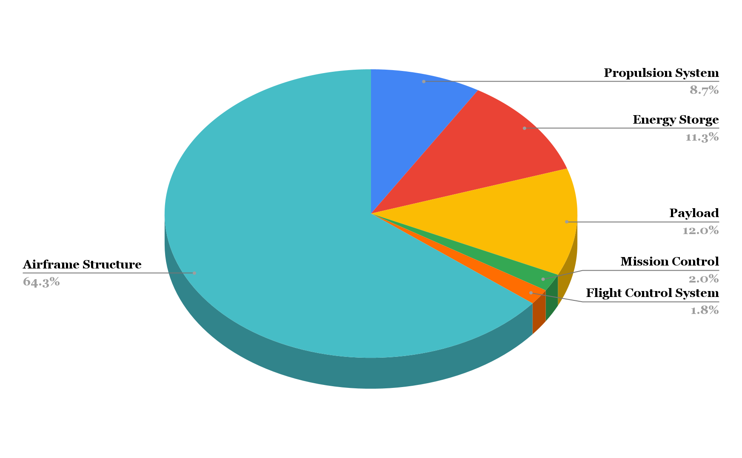
Figure 8: Aircraft component weight percentages
9. Structures and Materials
Polycarbonate (PC) serves as the primary structural material for the airframe because of its high thermal resistance, toughness, and compatibility with the expected loading conditions of the Jäger-QRF. During normal operation, the structure experiences aerodynamic lift along the wing, motor thrust, and vibration loads, as well as inertial forces generated during maneuvering. These forces produce wing bending, fuselage torsion, and localized stresses at the motor mounts, which the airframe must withstand. PC provides sufficient structural stiffness to resist excessive deformation under these loads.
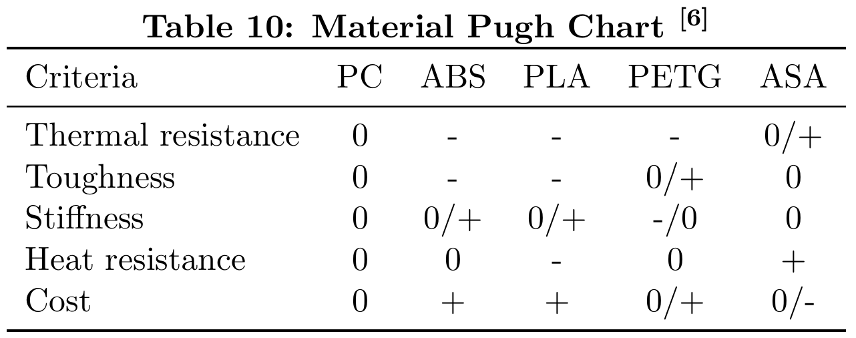
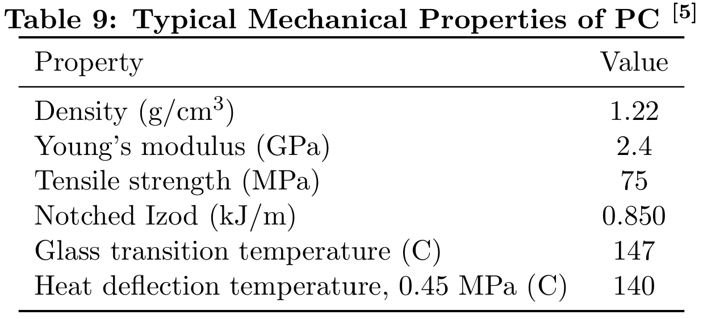
The material has a Young’s modulus of approximately 2.4 GPa, which supports the structural rigidity required for the airframe. In addition, PC exhibits relatively high toughness, which reduces the likelihood of brittle fracture during hard landings or impact events.

In addition to aerodynamic loading, the aircraft may encounter elevated temperatures during firefighting operations. However, the Jager-QRF targets early-stage fire suppression, where ambient temperatures remain significantly lower than those found in fully developed fires. These conditions are expected to remain below the glass-transition temperature of PC (147 °C), thereby maintaining the structure's mechanical integrity during operation. As a result, polycarbonate provides a suitable balance of strength, toughness, and thermal resistance for the intended mission profile.
With polycarbonate used as the primary structural material for the airframe, the engine mounts and tail booms are constructed from carbon fiber composite to maintain structural rigidity while minimizing weight in the aft section of the aircraft. Carbon fiber provides a significantly higher stiffness-to-weight ratio than polycarbonate, with typical composite Young’s modulus values exceeding 70 GPa depending on fiber orientation. In addition, carbon fiber composites exhibit glass-transition temperatures typically above 120 °C, ensuring that the tail structure maintains stiffness and structural integrity under the elevated thermal conditions that may occur during wildfire monitoring operations.
9.1 Structural Layout
The design uses a honeycomb infill pattern to maximize the airframe's strength-to-weight ratio while simplifying the internal structural layout. The structure must resist bending moments, thrust loads from the propulsion system, and inertial forces generated during maneuvering. The honeycomb geometry distributes loads through interconnected cell walls, which creates a lightweight internal structure with high in-plane shear strength and stiffness ^{[7]}.
Reducing structural weight is critical to maximizing the aircraft’s thrust-to-weight ratio and payload capacity. The honeycomb architecture supports this objective by providing structural rigidity while minimizing material usage.
Unlike conventional aircraft structures that rely on discrete load-carrying members such as spars, ribs, stringers, and frames, the honeycomb infill creates a distributed load-bearing structure. This distributed configuration spreads loads across the internal lattice and reduces localized stress concentrations that typically occur at structural members. Given the structure's relatively small scale and nearly nonexistent aerodynamic loads, a honeycomb infill provides sufficient stiffness and strength.
9.2 V-n Diagram
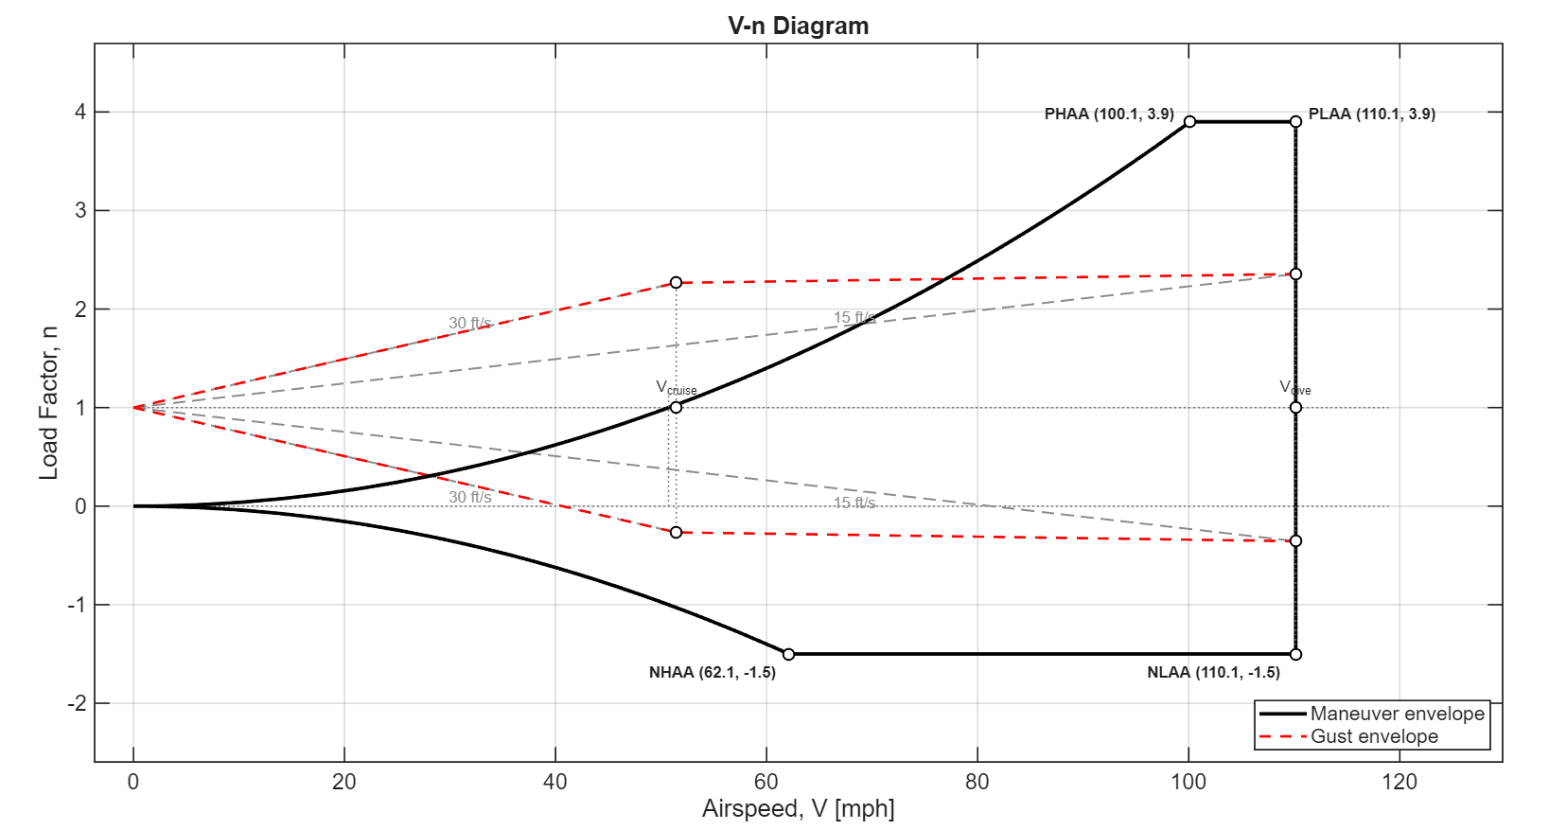
Figure 9: V-n Diagram (Maneuver and Gust Load Envelope)

The V-n diagram, or maneuver-and-gust load envelope, defines the structural and aerodynamic limits of our drone. The envelope describes the relationship between load factor (n) and airspeed (V) to help our team determine the reliability and performance of Jäger-QRF under varying flight conditions. The stall boundary defines the left side of the envelope and follows from the maximum lift coefficient (C_{L,max}) while the horizontal upper and lower boundaries correspond to the structural limit load factor. As airspeed increases, the wing produces greater lift, which allows the drone to sustain higher load factors.
For this configuration, atmospheric gusts generate significant aerodynamic loads, which are evaluated together with the maneuver envelope to ensure safe operation in forward flight. The positive and negative structural limits are approximately +3.9 and −1.5. The resulting envelope shows that the aircraft is stall-limited at lower airspeeds and structurally limited at higher load factors during forward-flight operation.
10. Static Stability
The Jäger-QRF remains longitudinally statically stable, maintaining a static margin of approximately 18–19% MAC depending on the payload configuration. The aircraft exhibits a static margin of 19.01% MAC with payload and 17.82% MAC without payload, indicating that payload deployment produces only a 1.19% change in static margin. This small shift demonstrates that the vehicle’s mass distribution effectively limits center-of-gravity migration during payload release by placing the heaviest components near the mid-fuselage. As a result, the aircraft maintains positive static longitudinal stability throughout the mission profile.
11. Dynamic Stability
The dynamic stability of the Jäger-QRF aircraft was evaluated at the cruise condition of 75 ft/s using a linearized flight-dynamics model constructed from aerodynamic stability derivatives computed in AVL. MATLAB scripts automatically generated AVL configurations, extracted the aerodynamic derivatives, and assembled the state-space system used to compute the dynamic eigenvalues. The resulting eigenvalue analysis identifies the classical longitudinal and lateral-directional modes expected for a small fixed-wing UAV and confirms stable longitudinal behavior with acceptable lateral-directional response for the intended mission. According to the handling-quality framework presented in the course lecture, the Jäger-QRF configuration corresponds to a Class I aircraft operating primarily in Category B flight phases, which include cruise and loiter operations typical of surveillance missions.
11.1 Longitudinal Dynamic Stability
The longitudinal dynamics of the Jäger-QRF aircraft consist of the short-period and phugoid modes. The computed handling-quality metrics are summarized in Table X. The short-period mode exhibits a natural frequency of ωₙ ≈ 4.83 rad/s and a damping ratio of ζ ≈ 0.32, which satisfies the Level 1 handling-quality requirement for a Class I Category B aircraft. This level of damping produces a well-damped pitch response, allowing the aircraft to respond quickly and predictably to pitch disturbances during maneuvering. The phugoid mode exhibits a natural frequency of ωₙ ≈ 0.52 rad/s with a damping ratio of ζ ≈ 0.01, indicating a lightly damped long-period oscillation typical of fixed-wing aircraft. Although the phugoid mode does not meet Level 1 damping requirements, it satisfies Level 2 handling-quality criteria, which is acceptable for surveillance-type UAV missions where long-period oscillations occur slowly and can be readily corrected by the flight control system.
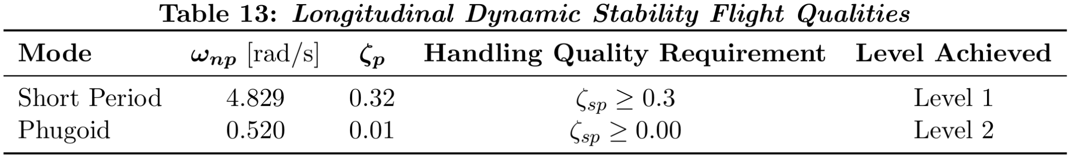

11.2 Lateral Dynamic Stability
The lateral-directional dynamics of the Jäger-QRF aircraft consist of the Dutch roll, roll subsidence, and spiral modes. The computed handling-quality metrics are summarized in Table 13. The Dutch roll mode exhibits a natural frequency of ωₙ ≈ 2.66 rad/s and a damping ratio of ζ ≈ 0.07. While the natural frequency satisfies the Level 1 requirement, the damping ratio falls slightly below the Level 1 threshold, resulting in Level 2 lateral handling qualities, which are typical for small UAV configurations. The roll subsidence mode exhibits a time constant of approximately τᵣ ≈ 0.42 s, satisfying the Level 1 requirement and indicating strong roll damping with rapid decay of roll disturbances. The spiral mode produces a time-to-double amplitude of approximately T₂,s ≈ 3.97 s, indicating a moderately unstable spiral divergence. Although this value falls below the Level 1 requirement, it remains within Level 2 handling-quality criteria, meaning the spiral divergence occurs slowly enough to be easily corrected by pilot input or the flight control system.
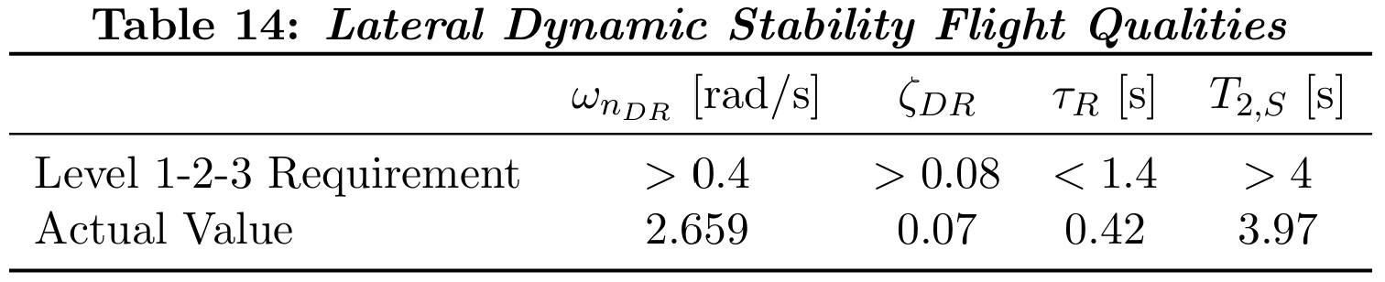

These dynamic stability metrics also guided the V-tail geometry optimization performed during the design process. Parameter sweeps of tail aspect ratio, taper ratio, and sweep angle were evaluated using the AVL-based dynamic model, and configurations were ranked based on the damping characteristics of the resulting eigenvalues. The final tail geometry was selected because it produced the most favorable dynamic stability while maintaining acceptable aerodynamic efficiency and structural feasibility. Overall, the configuration exhibits stable longitudinal behavior and acceptable lateral-directional dynamics consistent with small fixed-wing UAV platforms, meeting the handling-quality expectations for the maneuvering, cruise, and low-altitude operations required by the rapid-response firefighting mission. Future work could further improve dynamic stability through additional tail optimization or alternative configurations, such as adding a small downward vertical fin to enhance directional stability or investigating an X-tail configuration to increase yaw damping while maintaining a compact tail geometry.
12. Control Surfaces
The Jäger-QRF control surfaces were sized to provide maneuverability appropriate for wildfire monitoring and suppression missions while preserving stable cruise flight behavior. The aircraft must perform controlled turns around fire zones, reposition as fire conditions evolve, and maintain stable flight during observation and payload deployment. Based on comparisons with existing surveillance UAV platforms, the design targets moderate maneuver capability rather than aggressive performance. The selected maneuver targets are summarized in Table 15 and correspond to roll, pitch, and yaw rates appropriate for monitoring and loiter operations.
The aircraft uses a simplified control configuration consisting of ailerons for roll control and a V-tail assembly that provides both pitch and yaw control through symmetric and differential surface deflections. Flaps were not included in the design because the hybrid VTOL configuration eliminates the need for low-speed lift augmentation during takeoff and landing, allowing the aircraft to rely on rotor lift during VTOL operations while maintaining a simpler and lighter wing structure.
Control surface sizing was performed through an aerodynamic trade study using AVL simulations.Control surface sizing was performed through an aerodynamic trade study using AVL simulations. To ensure safe operation during contingency scenarios, the control surfaces were designed assuming a complete rotor shutdown during forward flight, requiring the aircraft to maintain aerodynamic control and perform an emergency fixed-wing-landing. Under this condition, aerodynamic control authority becomes the primary means of attitude regulation. Therefore, the control surfaces were sized using a conservative minimum aerodynamic control speed corresponding to approximately 1.2-1.3 times the stall speed, which represents the lowest airspeed at which the aircraft can maintain reliable aerodynamic control.
For the Jäger-QRF aircraft, the estimated stall speed is approximately 31 mph (45.9 ft/s), resulting in a minimum control design speed of approximately 55–60 ft/s. MATLAB scripts automatically generated AVL configurations, extracted the resulting control derivatives, and evaluated candidate geometries by varying the spanwise extent and chord fraction of the ailerons together with the control area of the V-tail surfaces. The evaluated configurations and resulting control authority are summarized in Table 15.
The trade study identified the smallest control surfaces capable of producing the required maneuver authority while maintaining acceptable aerodynamic and structural characteristics. Because aerodynamic control effectiveness increases with dynamic pressure, designing the surfaces at the minimum control speed provides a conservative margin that ensures adequate control authority at higher speeds, including the 75 ft/s cruise condition. The final configuration satisfies the maneuver targets within typical UAV control-surface deflection limits of approximately ±20°, as summarized in Table 15. These results confirm that the selected aileron and V-tail geometry provide sufficient roll, pitch, and yaw control authority while maintaining the stable dynamic characteristics identified in the aircraft stability analysis.
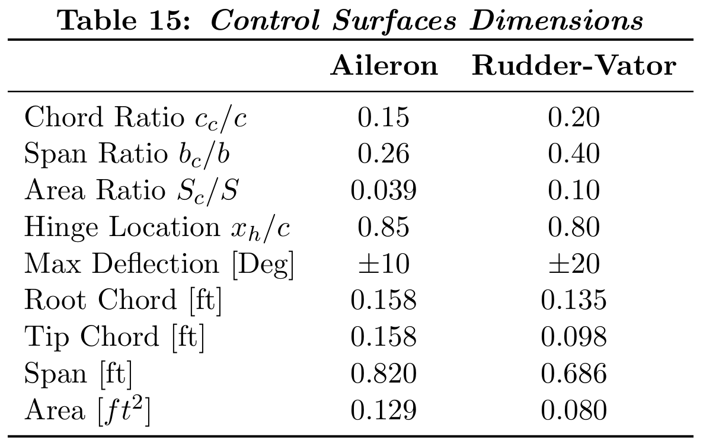 | 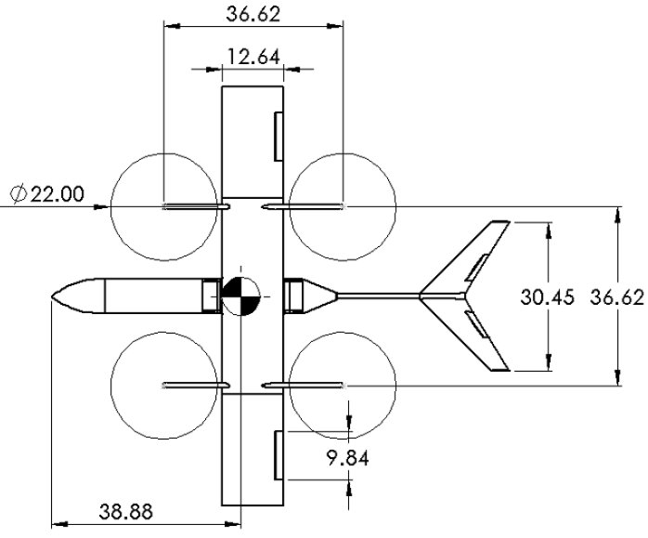  Figure 10: Jäger-QRF control surface layout.
13. Cost Analysis
The cost analysis evaluates the economic feasibility of the Jager-QRF hybrid VTOL firefighting UAV by estimating both acquisition and operating expenses over the system’s expected service life. The manufacturing cost estimate considers the primary propulsion components, the onboard energy storage system, and the structural airframe. These subsystems represent the major hardware cost drivers of the vehicle and produce an estimated baseline manufacturing cost of approximately $2,637 per UAV.
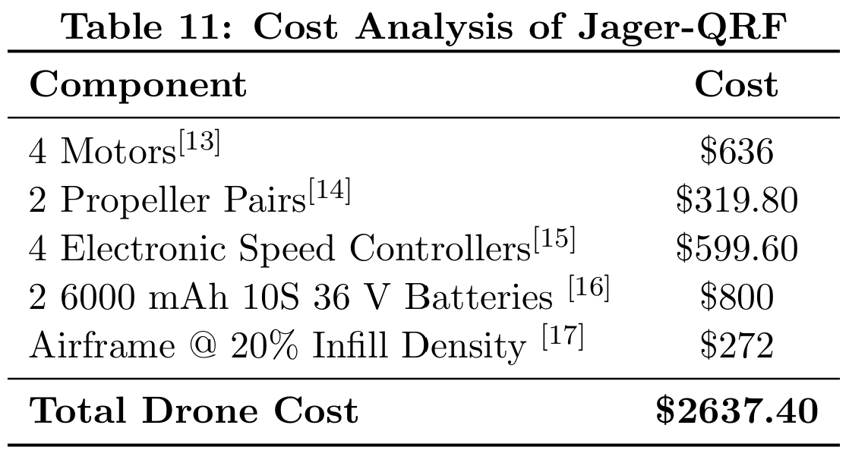
The UAV uses two batteries with a combined energy capacity of 0.37 kWh. Assuming a charging efficiency of 90% and an electricity price of $0.343/kWh, a full recharge costs approximately $0.141. Each full charge supports two sorties, which produces an energy cost of $0.0705 per mission or approximately $0.65 per flight hour. With an estimated 358 sorties per year, the electricity cost equals roughly $25 annually, or about $125 over a five-year operating period.
Operational costs include energy consumption, battery degradation, maintenance, and other consumables required during routine operation. Electric propulsion simplifies the operating cost structure compared with conventional combustion-powered aircraft because the system eliminates fuel logistics and reduces mechanical maintenance requirements.

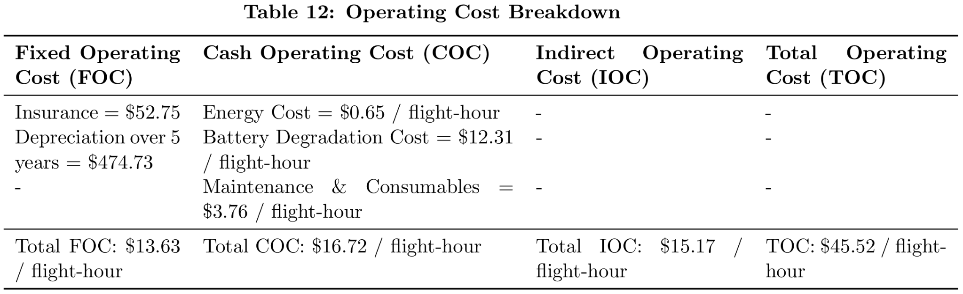
A break-even analysis evaluates the project's economic viability by estimating development costs, manufacturing costs per vehicle, and the expected sales price. Development expenses include engineering labor, prototype construction, testing, and certification-related costs. Comparing these expenses with the projected revenue per aircraft provides an estimate of the production quantity required to recover the initial development investment. Development costs were estimated at $1.35 million. This cost includes engineering labor assuming 4 engineers with a salary estimated at $126k a year[] and multiplying by 2 to represent a fully burdened engineer^{[19]}. Development costs also include prototype and testing estimated at $200k. Since Jager is presented as a firefighting drone, state and municipal testing is necessary for the drone to be sold to firefighting agencies which are in that domain. The cost for this regulatory testing is estimated at $150k. Assuming a sales price of $8,000 per unit^{[20]}, the contribution margin per drone is $5362.60, leading to a break-even production quantity of approximately 251 units. Considering that there are approximately 27000 fire departments in the USA^{[21]}, capturing less than 1% of the potential market would allow the project to recover its development investment, indicating that the Jager is economically feasible as a rapid-response aerial firefighting support platform.
14. Conclusion
The Jäger-QRF UAV demonstrates a feasible and effective solution for rapid-response aerial firefighting support. The hybrid VTOL fixed-wing configuration enables vertical takeoff, efficient cruise flight, stable hover for payload deployment, and safe return-to-base (RTB) operations while remaining within FAA small-UAS constraints. This capability allows the system to reach fire scenes quickly and perform targeted suppression during the early stages of a fire, when rapid intervention is most critical.
The aerodynamic, propulsion, and sizing analyses show that the aircraft meets the required cruise speed, hover performance, and mission endurance within the 55-lb MTOW class. Weight and balance analysis confirms a favorable CG location and positive static margin across payload configurations, while the dynamic stability analysis indicates acceptable longitudinal and lateral-directional handling qualities consistent with a Class I Category B UAV. Structural and material selections provide adequate stiffness, strength, and thermal resistance for operation in wildfire monitoring environments while maintaining a lightweight airframe suitable for VTOL flight. The control surface sizing study further confirms that the aileron and V-tail configuration provides sufficient aerodynamic control authority to meet the maneuver requirements and maintain controllability during contingency scenarios such as rotor shutdown during forward flight. Combined with the low operating costs and feasible production economics identified in the cost analysis, the results demonstrate that the Jäger-QRF platform is both technically and economically viable.
The Jäger-QRF design demonstrates a balance between mission performance and engineering feasibility. By combining rapid-response capabilities with efficient cruise performance and stable flight dynamics, the aircraft provides a solution between fire ignition and ground crew arrival. The VTOL configuration features precise payload deployment while maintaining robustness under flight conditions. Additionally, the system’s low operating cost reinforces the practicality of widespread deployment across fire stations. The current design represents a viable solution for early stage fire suppression.

Appendix A: References

[1] “Fire Is Fast and Getting Faster.” U.S. Fire Administration: Working for a Fire-Safe America, U.S. Fire Administration, 5 Apr. 2024, www.usfa.fema.gov/blog/fire-is-fast-and-getting-faster/

[2] Castellnou Ribau, M., Bachfischer, M., Guarque, P., Estivill, L., Miralles Bover, M., Ruiz, B., Pagès, J., Verhoeven, B., Ntasiou, Z., Stokkeland, O., van Heerwaarden, C., Roelofs, T., Janssens, M., Stoof, C. R., and Vilà-Guerau de Arellano, J.: Integrating fireline observations to characterize fire plumes during pyroconvective extreme wildfire events: implications for firefighter safety and plume modeling, Atmos. Meas. Tech., 18, 7805–7831, https://doi.org/10.5194/amt-18-7805-2025

[3] Austin, R., Unmanned Aircraft Systems: UAVs Design, Development and Deployment, 2nd ed., Wiley, Chichester, UK, 2010

[4] Federal Aviation Administration, Remote Pilot – Small Unmanned Aircraft Systems Study Guide, FAA, 2016.

[5] "Lexan sheet technical manual" (PDF). SABIC. 2009.

[6] MatWeb. (n.d.). Material property data. Retrieved from https://www.matweb.com

[7] Callister, William D., and David G. Rethwisch. Materials Science and Engineering: An Introduction. Wiley, 2018.
[8] Li, Fang, and Oliver Kunze. “A Comparative Review of Air Drones (Uavs) and Delivery Bots (SUGVs) for Automated Last Mile Home Delivery.” MDPI, Multidisciplinary Digital Publishing Institute, 3 Apr. 2023, www.mdpi.com/2305-6290/7/2/21.
[9] SpaceX, www.spacex.com/vehicles/starship. Accessed 11 Feb. 2026.

[10] 18115169114. “News - How Long Does Agricultural Drone Last: Hongfei Drone.” How Long Does Agricultural Drone Last, www.hongfeidrone.com/news/how-long-does-agricultural-drone-last/#:~:text=However%2C%20the%20service%20life%20varies,is%20also%20an%20important%20consideration. Accessed 11 Mar. 2026.
[11] Drone Battery Replacement and Its Importance for Optimal Performance - Herewin, 21 July 2025, www.herewinpower.com/drone-battery/drone-battery-replacement-and-its-importance-for-optimal-performance-2/#:~:text=Reduced%20Flight%20Time,years%20before%20it%20needs%20replacement.
[12] “Charging Efficiency → Term.” Energy, 1 Jan. 1970, energy.sustainability-directory.com/term/charging-efficiency/.

[13] “VL6013 KV210 VTOL UAV Motor for 13kg Max Thrust Drones.” T-MOTOR, store.tmotor.com/product/vl6013-heavy-drone-motor-for-uavs.html. Accessed 11 Mar. 2026.
[14] “VZ22X7.4 22.” T-MOTOR, store.tmotor.com/goods-1497-VZ22%2A74.html. Accessed 11 Mar. 2026.
[15] “V80A 14s UAV FOC ESC - High Performance & Fast Response.” T-MOTOR, store.tmotor.com/product/v80a-bldc-foc-drone-esc.html. Accessed 11 Mar. 2026.
[16] “Li-Ion 6000mah 10s 36v Battery Pack.” MaxAmps Lithium Batteries, maxamps.com/products/li-ion-6000mah-10s-36v-battery-pack?srsltid=AfmBOoon564idnWXtH8Ft_o-Rtg4dP3IUX6J3CCwpEzstmEXBpZ_bQ47. Accessed 11 Mar. 2026.
[17] “Polycarbonate Spool.” Bambu Lab US Store, us.store.bambulab.com/products/pc-filament. Accessed 11 Mar. 2026.
[18] U.S. Bureau of Labor Statistics. “U.S. Bureau of Labor Statistics.” Bls.gov, U.S. Bureau of Labor Statistics, 29 Aug. 2024, www.bls.gov/.
[19] ‌Roskam, Jan. Airplane Design : Part VIII : Airplane Cost Estimation : Design, Development, Manufacturing and Operating. Lawrence, Kansas, Darcorporation, 2006.
[20] Foxtech Ayk-250 Long-Endurance VTOL Inspection and Mapping Drone, www.foxtechfpv.com/foxtech-ayk-250-vtol.html. Accessed 11 Mar. 2026.
[21] National Fire Protection Association. “NFPA.” Nfpa.org, 2023, www.nfpa.org/.
[22] Battalion Chief Brush Rig Engine Hazmat Helicopter LG River Rescue Mod Rescue, www.sandiego.gov/sites/default/files/2024-02/cy23-station-responses.pdf. Accessed 11 Mar. 2026.
[23] Mallick, P. K., Fiber-Reinforced Composites: Materials, Manufacturing, and Design, 3rd ed., CRC Press, 2007.

Appendix B: Figures

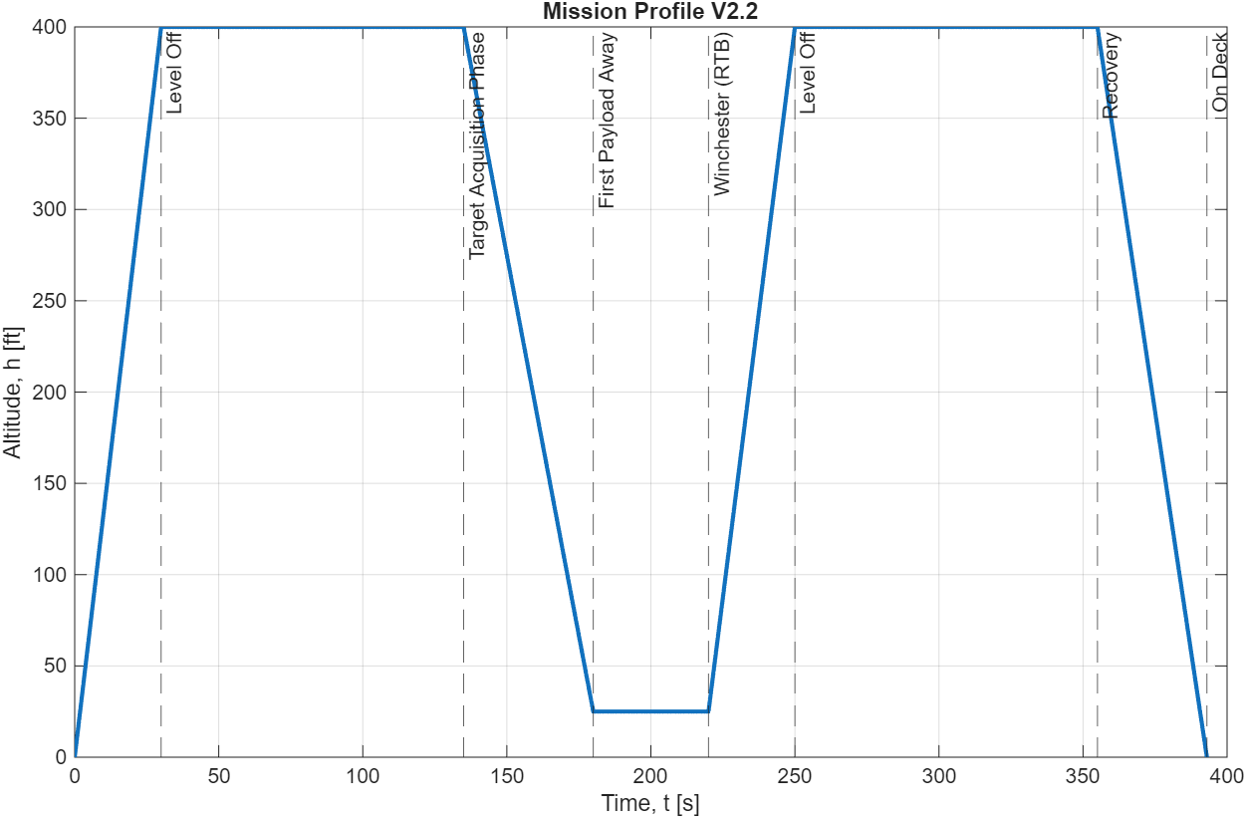
Figure B1: Mission profile for VTOL UAV, where the blue line denotes the change in altitude over time

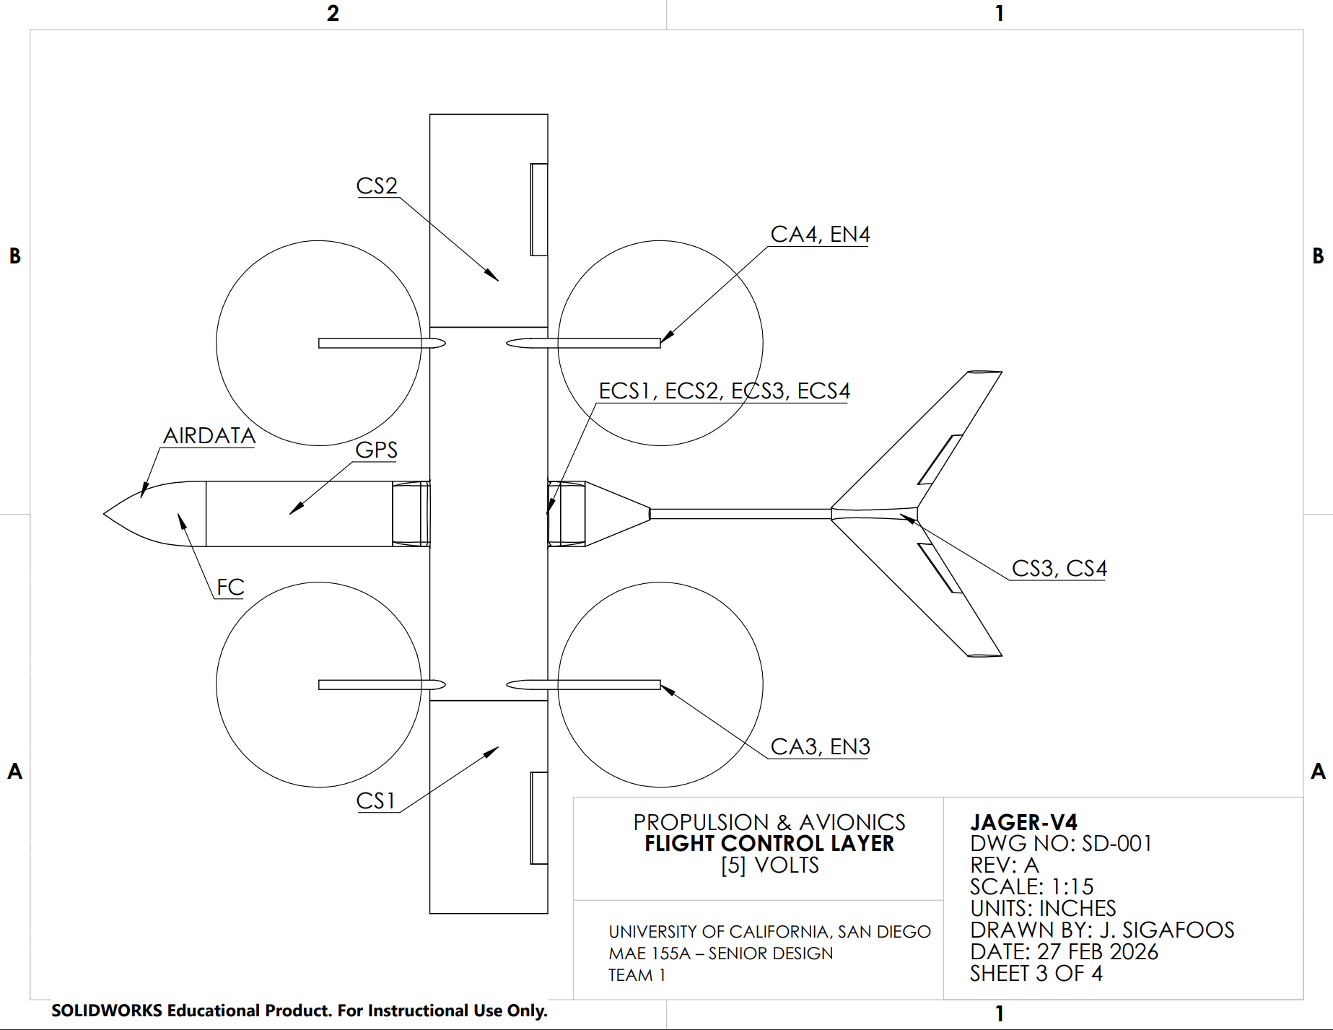

Figure B8: Flight control, ref “Table C1”
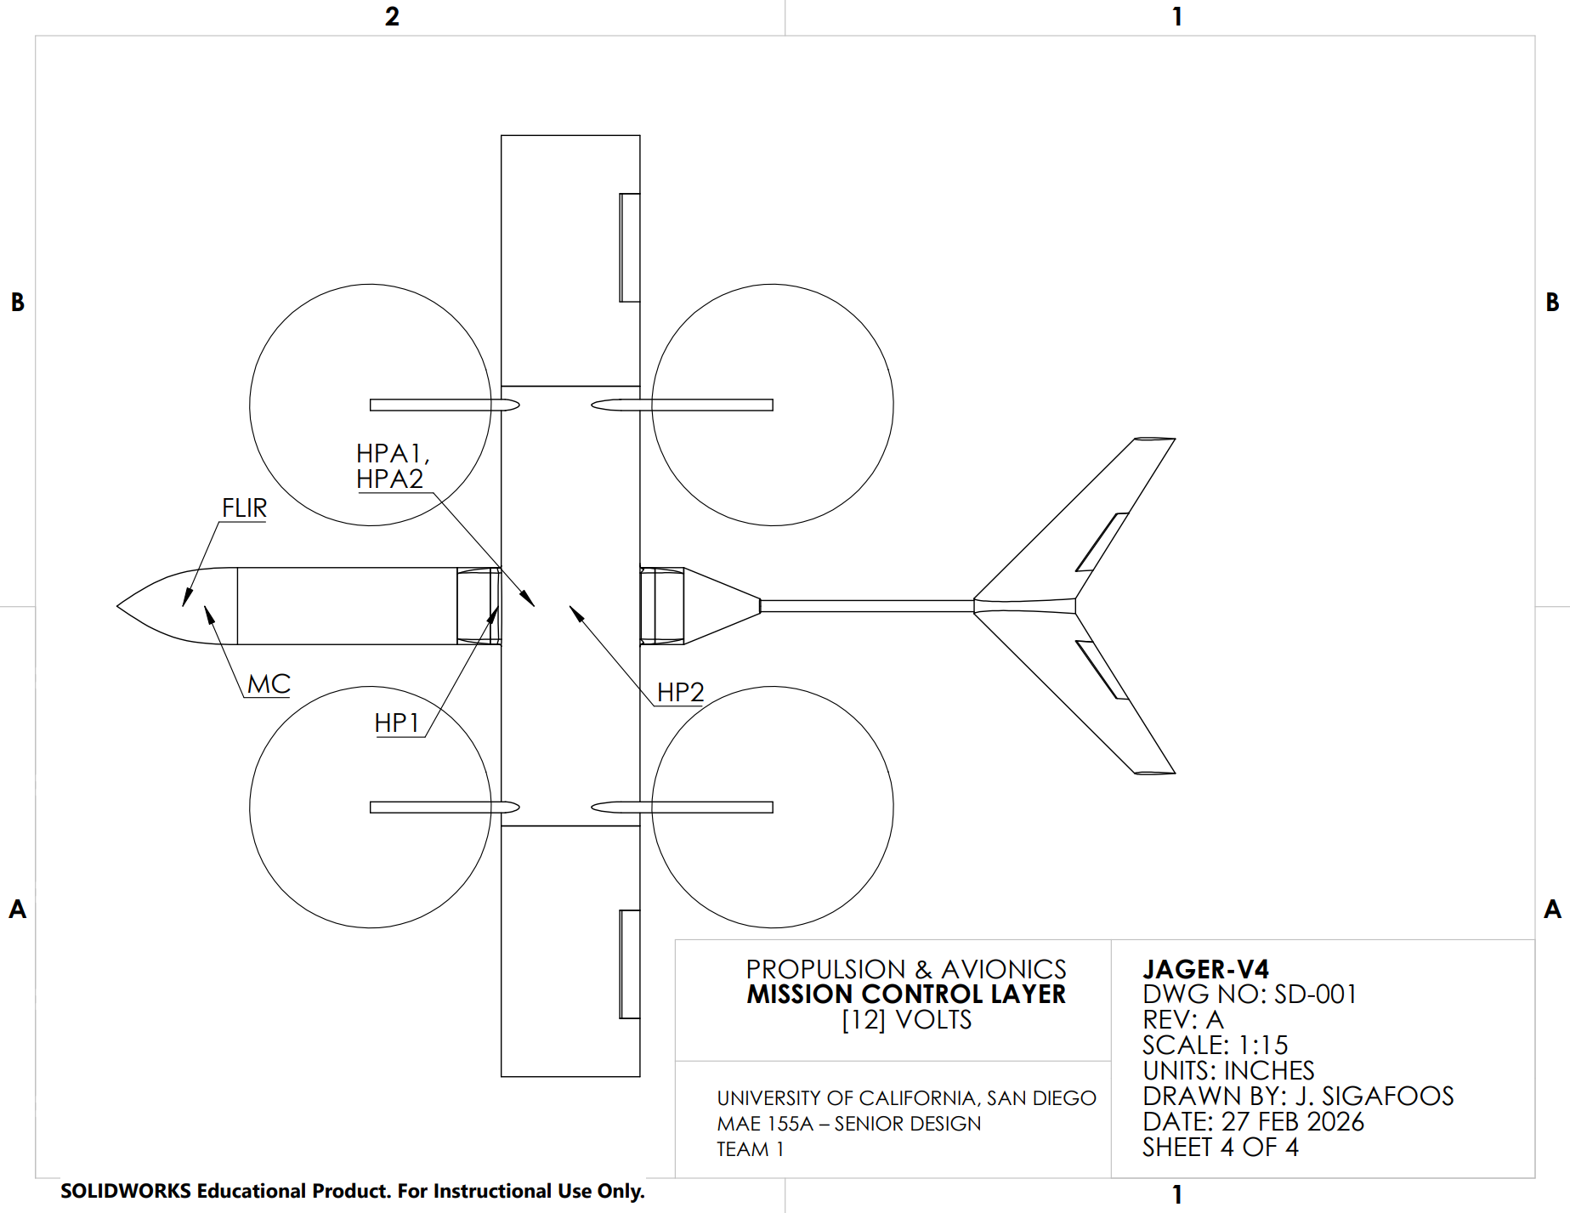

Figure B9: Mission control, ref “Table C1”
Appendix C: Tables

Item | Description
M1 | Motor for FWD LH Rotor
M2 | Motor for FWD RH Rotor
M3 | Motor for AFT LH Rotor
M4 | Motor for AFT RH Rotor
R1 | FWD LH Rotor
R2 | FWD RH Rotor
R3 | AFT LH Rotor
R4 | AFT RH Rotor
ESC1 | Electronic Speed Controller 1: Sends Power to M1
ESC2 | Electronic Speed Controller 2: Sends Power to M2
ESC3 | Electronic Speed Controller 3: Sends Power to M3
ESC4 | Electronic Speed Controller 4: Sends Power to M4
B1 | Battery 1: S10 (37.0 / 42.0 Volts)
B2 | Battery 2: S10 (37.0 / 42.0 Volts)
HP1 | Hard point 1: FWD ordinance
HP2 | Hard point 2: AFT ordinance
FLIR T | Forward-looking infrared turret
FC | Flight controller
MC | Mission Controller
HPA1 | Hard Point Actuator Solenoid 1
HPA2 | Hard Point Actuator Solenoid 2
AIRDATA | Air speed indicator
CS1 | LH Aileron Control Servo
CS2 | RH Aileron Control Servo
CS3 | LH V-tail Control Servo
CS4 | RH V-tail Control Servo
EN3 | LH AFT Motor Conversion Encoder
EN4 | RH AFT Motor Conversion Encoder
CA3 | LH AFT Motor Conversion Servo
CA4 | LR AFT Motor Conversion Servo
GPS | GPS

Table C1: Itemized Avionics and Components

BCR Report

Jäger-V5: Fire Fighter Drone

Presented To:
University of California, San Diego
Department of Mechanical and Aerospace Engineering

MAE 155A
Professor John T. Hwang

Prepared By:
Group 1: Harshil Patel, John Sigafoos, Angel Ochoa, Juan Sanchez, Sara Chowdhury, and Analisa Veloz

Motivation:

The motivation for this project is to design an unmanned aerial vehicle (UAV) capable of providing aerial firefighting support during active fires. The UAV is intended to supply real-time aerial visibility to firefighters and to help identify safe and efficient access paths, improving situational awareness and operational effectiveness and reducing risk to personnel, while carrying a payload capable of dropping and extinguishing a specific fire radius.

Design Problem:

The UAV must satisfy specific mission requirements to support aerial firefighting operations. The UAV shall operate at or below the Federal Aviation Administration (FAA) altitude limit of approximately 400 ft above ground level (AGL) and must be capable of reaching a fire scene before ground-based firefighting vehicles. To meet this requirement, the UAV shall cruise at a minimum speed of 51.43 mph and deploy the first of two fire extinguisher payloads with a combined mass of 6.6 lbs within the first 180 seconds of takeoff. Upon arrival at the fire scene, the UAV shall be capable of identifying the target area, maneuvering to the appropriate release position, and activating a payload deployment mechanism. Each payload shall be capable of suppressing a fire within a radius of 3 m. Following payload deployment, the UAV shall safely return to the launch station without sustaining structural or functional damage.

Design:
The UAV design consists of a quadcopter configuration, a fixed-wing airframe, and a tilt-rotor system. This configuration enables vertical takeoff and landing (VTOL) and sustained hovering during payload deployment, eliminating the need for a runway, an essential requirement for rapid deployment from firefighter stations where response time is critical. During takeoff and landing, all rotors operate in VTOL mode. After transition, the two rear rotors tilt aft to enable forward flight, while the fixed wing provides most of the required lift during cruise. In this flight regime, the battery's power demand is significantly lower than in hover, as the rotors are no longer required to continuously generate lift. Control during cruise and maneuvering is achieved primarily through conventional control surfaces, including ailerons, a combined elevator and rudder from a V-tail, with increased power demand during aggressive maneuvers or transition phases. The fuselage is sized to accommodate onboard avionics, two fire-extinguisher payloads, and the associated deployment mechanisms. A forward-mounted FLIR (forward-looking infrared) camera is integrated into the UAV's nose to provide thermal imaging and situational mapping capabilities for target identification and navigation in low-visibility fire environments.

Significance:

The significance of Jager lies in its ability to serve as a rapid first responder in emergency fires, where every second is critical and early intervention can save lives [1]. In addition, Jager provides technical and situational assistance to firefighters operating in hazardous environments, improving their safety and effectiveness by enhancing awareness of fire location, hazards, and access routes, thereby supporting firefighter well-being and reducing operational risk.
Aircraft Specifications:
Parameter Symbol Value Units  Cruise Speed V_{cruise} 51.4286 mph  Total Time of Flight TOF 393.0 seconds  Range R 4.5 miles  Cruise Altitude h_{Cruise} 400 ft  Payload Deployment Altitude h_{Deploy} 25 ft  Vertical Climb Rate V_{climb} 9.09 mph  Table 1: Mission Specifications | Parameter Symbol Value Units  Wing Area S 10.76 ft²  Wingspan b 1.91 ft  Aspect Ratio AR 6 —  V-tail Area S_{tail} 0.1178 ft²  Wing Loading W/S 8.28 lb/ft²  Chord c 1.052 ft  Table 2: Wing Geometry

Parameter Symbol Value Units  Number of Rotors N 4 —  Disk Loading D_{L} 6.2656 lb/ft²  Total Disk Area A_{tot} 8.78 ft²  Rotor Diameter D 1.67 ft  Table 3: Rotor Disk Geometry | Parameter Symbol Value Units  Payload Weight W_{p} 6.6 lb  Battery Weight W_{b} 5.4 lb  Empty Weight W_{e} 43 lb  Max Take-Off Weight MTOW 55 lb  Table 4: Aircraft Mass Properties

Parameter | Symbol | Value | Units
Max Lift Coefficient | C_{Lmax} | 1.23 | —
Lift Coefficient at no angle of attack | C_{L0} | 0.2 | —
Lift Curve Slope | C_{La} | 6.79 | —
Induced Drag | C_{Di} | 0.099 | —
Parasitic Drag | C_{D0} | 0.074 | —
Table 5: Aerodynamic Coefficients
Technical Drawing:
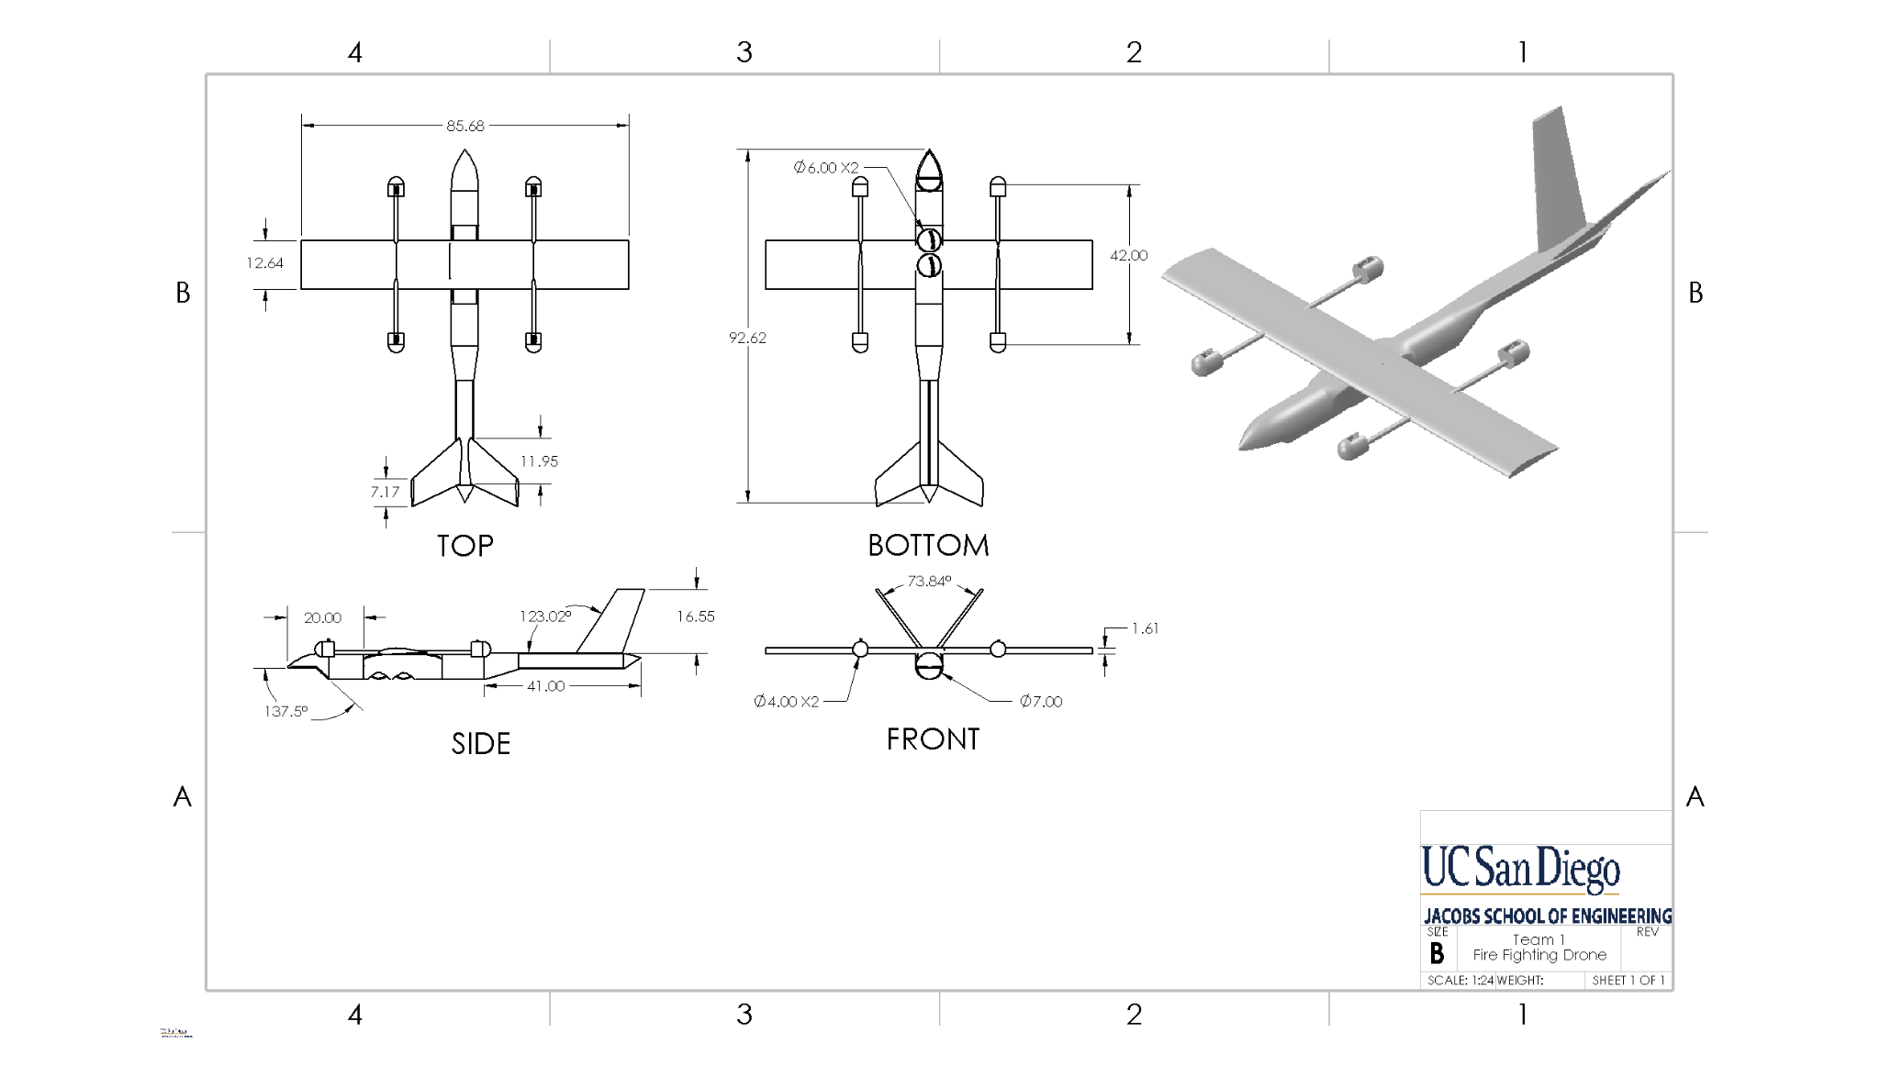
Figure 1: Technical Drawing
Introduction:

In today's era, wildfires and structural fires present rapidly evolving, high-risk environments where limited visibility, uncertain access routes, and time-critical decision-making significantly endanger first responders ^{[2]}. In today’s technological world, small unmanned aerial systems (sUAS) have enabled aerial reconnaissance and thermal imaging support for emergency response; however, conventional multirotor platforms are constrained by limited range and endurance, while fixed-wing UAVs lack vertical takeoff, landing, and hover capabilities required for precise operations^{[3]}. Hybrid VTOL configurations show promise by combining the endurance and cruise efficiency of fixed-wing aircraft.

This project addresses the design of a rapid-response firefighting support UAV capable of operating within FAA small UAS constraints while providing real-time aerial visibility and localized fire-suppression capability ^{[4]}. The primary objective of this drone is to achieve sufficient cruise speed to arrive at the target area ahead of ground vehicles, transition to stable hover for payload deployment, and safely return to base while maintaining structural and operational integrity. Furthermore, these key enabling technologies include electric VTOL propulsion, lightweight composite structures, high-energy-density batteries, and thermal imaging sensors. The overall system performance is evaluated using measures of merit, including cruise speed, stall speed, response time, payload fraction, hover endurance, and mass efficiency, which ensures mission feasibility.

Concept of Operations:

The operational mission profile for Jager is as displayed in Figure B1. Jager is autonomously deployed from a local fire station in VTOL mode, maintaining a vertical climb rate, VClimb, until leveling off at cruise altitude, hCruise, transitioning into forward flight while maintaining V_{Cruise} [Table 1]. Upon approaching the disaster site, Jager will transition into the target acquisition phase, loitering and scanning until descending into the payload deployment phase. In hover, Jager will align over the fire while the MC or mission controller uses FLIR turret sensor data to signal and command the flight controller (FC) for optimal deployment conditions [Table 6]. After the first deployment at 180 seconds after takeoff, Jager has additional power available to allocate an additional 45 seconds in hover to deploy a second fire extinguisher, as required [Figure B1]. Following a completed payload delivery, Jager will enter Winchester state and return to base (RTB), maintaining V_{Cruise} at h_{Cruise} . Upon approach to the fire station, Jager will enter the recovery phase, descending in VTOL mode to a precise landing on ground support equipment (GSE), where a single-man crew will rearm and recharge Jager.

Initial Sizing:

Given the mission and payload criteria, we found that the solution existed in the 55lb class of urban air mobility (UAM) package delivery drones. Truly a unique take on the package delivery drone; initial sizing began with power requirements for cruise, hover, and hover-climb. Researched component values such as battery densities and baseline electrical efficiencies were employed to calculate our initial battery mass fraction [Table C3].
We then began defining the required constraint equations using MATLAB in a series of consecutive iterations. We plotted the constraint curves for power requirements and wing loading [Figure B3]. The most constraining parameters we found were the power required to climb and our stall limitation, with a 2% margin of safety bringing us to our final values [Figure B3].

Concept:

The concept took shape naturally and colinearly with Initial sizing and mission planning development. The closest thing that had been done to this mission was the recent popularization of delivery drones [8]. We realized early on that especially for the technical and precise nature of the payload delivery we needed to model the same hover performance as a delivery drone, giving us the quad copter configuration with 4 rotors [8].
However, in accordance with our engineering goals we decided to incorporate a blended VTOL and cruise configuration in an effort to optimize delivery performance, speed, and battery efficiency for a larger relative payload and robust avionics suite. We next explored rotor configuration, to optimize on weight efficiency we decided to go with a quad copter design that converted into a twin pusher configuration in cruise. After exploring potential disk loading configurations we decided that having 4 larger propellers that only two of which were “dead weight” in cruise, optimizing weight efficiency and power efficiency [Table 3].
When it came time for fuselage configuration we wanted to minimize drag, some more skeletal type designs had more weight savings, but would presumably induce more drag especially with our cruise speed, for which the purpose of cruise was to minimize energy consumption in route [3]. Thus, we chose a tubular design focused on aerodynamics. When we sized the fuselage we set out nose to tail length about even with the wing span, anticipating the length would surely change later down the iterative process like weight and balance. One last important fuselage configuration was the “chin” cut out below the nose to give the FLIR turret good visual opportunities.
Landing gear was deliberately absent for a few reasons, first of which were weight concerns with a growing drone. Additionally, with the VTOL design we really didn't need to consider wheels for rolling takeoff and landing. And lastly we realized that because of the very specific mission profile of our drone that called for the take off and landing at the same place every time, we could use this opportunity to take a page from Space x’s Starship and choose to launch and land from GSE or ground support equipment that could support landing and take off [9].
Lastly we explored tail configurations, With such a lightweight drone, compared to other vehicles, of course we wanted to consider something with stability. That’s where the V-tail configuration comes into play. The dihedral nature of the V-tail induces restoring moments along the roll axis in cruise[3]. Additionally, having a V-tail in the configuration we have with pusher props in cruise keeps all of our control and lifting surfaces out of turbulent air, optimizing for efficiency and stability.

Aerodynamics:

Aerodynamic performance was modeled using a quadratic drag polar and a lift coefficient curve. The key aerodynamic parameters are tabulated in Table 5. A semi-empirical formula was used to simulate the lift coefficient of the aircraft over angle of attack, presented in Figure B4. All aerodynamic parameters were calculated with the assumption of inviscid flow, substantiated by the aircraft’s low Reynold’s number flight conditions. With the inviscid assumption, lift equates to weight which produces a max lift coefficient of 1.23. The drag polar indicates a maximum lift-to-drag ratio of 10.1 occurring at approximately a $C_{D}$ value of 0.075 which corresponds to optimal cruise condition. The total drag coefficient was expressed as the sum of parasitic drag and induced drag. A parasitic drag coefficient of 0.037 was assumed, consistent with similar configurations. The Oswald efficiency factor was estimated to be 0.8. This formulation allows evaluation of lift-to-drag ratio and our cruise efficiency. A moderately cambered airfoil was selected to provide positive lift at low angles of attack. An airfoil with a good lift-to-drag performance was prioritized in which the NACA 4412 airfoil was ultimately selected. In regards to our aerodynamic parameters, the max ratio of lift to drag was computed to be 10.1.

Propulsion:

Conceptually speaking, for all drones of this weight class and delivery drones we referenced all used electric propulsion systems [3]. With such a small package having a less mechanically complex drone was certainly a driving force in our selection. The transfer of fuel to motors, or the transfer of mechanical power to motors via drive shafts would only add complexity and reduce reliability. The use of an electric power system is also a more manageable and realistically implemented integration into current fire fighting systems requiring minimal infrastructure and maintenance. Lastly, electronic components for small drones are readily available in today's modern economy.
The Propulsion system design began with battery selection. Based on our Wb/W0 percentage, we chose two S10 batteries in parallel to meet the energy requirements [Figure B7, Table C2]. Two separate batteries were also convenient for weight and balance optimization, allowing us to make precise changes to the moment arms. The batteries defined the propulsion system in terms of (37 - 42)Volts DC. Iterating on our MATLAB sizing script, we calculated a target thrust output for each propeller, a target KV for each motor, and maximum power output for each motor [Table C4]. With a radius of 22 inches from our disc loading ratio used previously in power sizing equations, optimizing for efficiency for spending time in hover [Table C4]. Lastly, we considered engine control and found ECS’s, or Electronic Speed Controllers, that could handle the voltage of our system [Table C4].
Future Propulsion work on Jager will explore ESC cooling, and wire harness design and integration.

Weight and Balance:

A detailed weight-and-balance analysis was performed to determine the drone's center of gravity (CG) location and assess its static stability. All major subsystems were itemized, including the propulsion system, airframe structure, energy storage, payload, mission & flight control system. Each component of the subsystem was assigned a longitudinal position, x, measured from the nose reference datum, and the corresponding moments were calculated. The drone’s center of gravity was calculated to be X_{CG} = 28.02 in aft of the nose. The mean aerodynamic chord (MAC) of the wing is 12.63 in, with the quarter-chord reference location at 27 in from the nose which places the CG slightly aft of the aerodynamic reference point. This placement is viable for a trimmed cruise flight while maintaining sufficient stability for transition and hover operations.

Using the MAC to normalise the CG and neutral point, the longitudinal static stability was assessed. With the CG at 31.86% MAC and the NP at 48.47%, the configuration is positive, with a static margin of 16.61%. The mass distribution is structured to limit CG excursions during payload deployment, with the heavy components placed near the mid-fuselage. The pie chart shows the overall weight breakdown is dominated by the airframe structure (64.3%), followed by payload (12%), energy storage (11.3%), and propulsion (8.7%), with avionics and control systems comprising the remaining mass [Figure B2]..

Structures and Materials:

V-n Diagram:
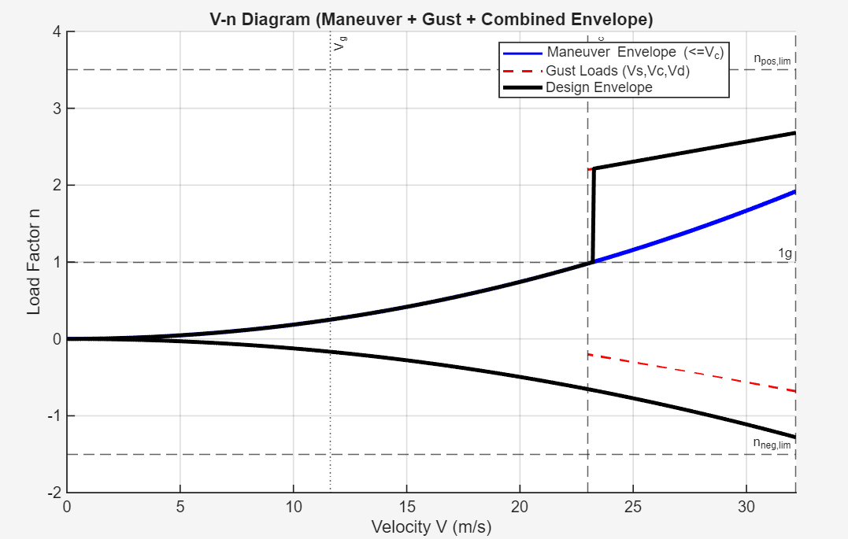
Figure 2: V-n Diagram
Figure 2 shows the load factors resulting from system maneuvers and atmospheric gusts. The left boundary represents the stall limit, based on the maximum lift coefficient $C_{L_{max}}$. The horizontal upper boundary corresponds to the structural limit load factor. In our configuration, gust loads become the governing factor at higher speeds, particularly during climb and cruise. Due to its low wing loading, the aircraft is more sensitive to vertical gusts. Thus, the final wing envelope is primarily dictated by gust loads rather than maneuver limits. The maximum positive design load factor is 2.691 g, which corresponds to a wing lift force of 650 N.

Material Discussion:

Polycarbonate (PC) is the selected structural material for the airframe due to its high thermal resistance, toughness, and suitability for the Jager's expected loading conditions. During a routine mission, the structure will experience lift along the wing, motor thrust and vibrations, and inertial loads during maneuvering. These loads cause wing bending, fuselage torsion, and stresses at the motor mounts, all of which the structure is expected to resist. The Young’s Modulus of PC is approximately 2.4 GPa, providing sufficient stiffness to prevent excessive structural deformation under these loads. PC is also less likely to sustain brittle fractures from hard impacts due to its relatively high toughness.
Property | Value
Density (g/cm³) | 1.22
Young's modulus (GPa) | 2.4
Tensile strength (MPa) | 75
Notched Izod (kJ/m) | 0.850
Glass transition temperature (C) | 147
Heat deflection temperature, 0.45 MPa, (C) | 140
Table 6: Typical Mechanical Properties of PC ^{[5]}

Criteria | PC (Baseline) | ABS | PLA | PETG | ASA
Thermal resistance | 0 | - | – | – | 0/+
Toughness | 0 | - | – | 0/+ | 0
Stiffness | 0 | 0/+ | 0/+ | –/0 | 0
Heat resistance | 0 | 0 | – | 0 | +
Cost | 0 | + | + | 0/+ | 0/–
Table 7: Material Pugh Chart ^{[6]}
In addition to aerodynamic stresses, Jager will be exposed to the heat of a developing fire, which will deform the structure. However, because the Jager is intended for early-response firefighting operations, it is likely to encounter decreased temperatures from the underdeveloped fire. This decrease in temperature is expected to remain below the glass transition temperature of the PC, thereby maintaining its structural integrity and making it a suitable material for its intended mission.

Structural Layout:

A honeycomb infill pattern was selected to optimize the strength-to-weight ratio of the structural components and simplify the internal layout. The airframe must withstand bending moments, thrust loads, and other forces. The mechanical properties of honeycombs are anisotropic, allowing their geometry to distribute loads efficiently through interconnected cell walls, thereby creating a lightweight internal structure with high in-plane shear stress and stiffness.^{[7]} Reducing structural weight is critical to maximize thrust-to-weight ratio and payload capacity.

Unlike traditional aircraft structures, which rely on load-carrying members such as spars, ribs, stringers, and frames, the honeycomb infill provides a distributed load-bearing structure. The distributed structure reduces stress concentrations that would occur at the structural members, eliminating the need for them. Given the structure's relatively small scale and nearly nonexistent aerodynamic loads, a honeycomb infill provides sufficient stiffness and strength.

Cost Analysis:

The Jager-V2 hybrid VTOL firefighting UAV was conducted to evaluate the economic feasibility of the system by estimating both acquisition and operational expenses over its expected service life. The baseline cost of manufacturing was determined based on the major propulsion system, the energy storage system, and the structural system, bringing the total cost of hardware approximately $2638.

Component | Cost
4 - Motors | $636
2 - Propeller Pairs | $319.80
4 - Electronic Speed Controllers | $599.60
2 600mAH 10S-36 V Batteries | $800
Airframe @ 20% Infill Density | $272
Total Drone Cost | $2637.40

The UAV uses two batteries with a combined energy capacity of 370 Wh (0.37 kWh). Assuming a charging efficiency of 90% and an electricity price of $0.343/kWh, the cost of a full recharge is approximately $0.141. Since each full charge supports two sorties, the energy cost per mission is $0.0705, which corresponds to roughly $0.65 per flight hour. With an estimated 358 sorties per year, the annual electricity cost is about $25 or $125 over a 5 year period.

Operating costs were estimated using the standard aircraft cost model where the Total Operating cost (TOC) = Direct Operating Cost (DOC) + Indirect Operating Cost (IOC). The DOC includes both Fixed Operating Cost (FOC) and Cash Operating Cost (COC). The fixed operating cost includes insurance and depreciation. The insurance was estimated at 2% of the drone value and depreciation on the other hand accounts for the cost of a tangible asset over its useful life. The COC includes energy cost , battery degradation cost and other maintenance and consumables costs. The indirect Operating Cost is assumed to be 50% of the DOC.

Fixed Operating Cost (FOC) | Cash Operating Cost (COC) | Indirect Operating Cost (IOC) | Total Operating Cost (TOC)
Insurance = $52.75 | Energy Cost = $0.65 / flight-hour | - | -
Depreciation over 5 years = $474.73 | Battery Degradation Cost = $12.31/ flight - hour | - | -
- | Maintenance & Consumables = $3.76 / flight-hour | - | -
Total FOC: $13.63/ flight-hour | Total COC: $16.72 / flight-hour | Total IOC: $15.17 / flight-hour | TOC: $45.52 / flight-hour
A break-even analysis was also performed to evaluate project viability. Development costs were estimated at $1.35 million, including engineering labor, 4 engineers with average salary at $126k which bring the total around $ 1 million, the prototype and testing costs around $200k and municipal or regulatory testing around $150k. Assuming a sales price of $8000 per unit, the contribution margin per drone is $5362.60/ leading to a break-even production quantity of approximately 251 units. Considering that there are approximately 27000 fire departments in the USA, capturing less than 1% of the potential market would allow the project to recover its development investment, indicating that the Jager is economically feasible as a rapid-response aerial firefighting support platform.

Cost Analysis:
The Jager-QRF hybrid VTOL firefighting UAV was conducted to evaluate the economic feasibility of the system by estimating both acquisition and operational expenses over its expected service life. The baseline cost of manufacturing was determined based on the major propulsion system, the energy storage system, and the structural system, bringing the total cost of hardware approximately $2638.

Component | Cost
4 - Motors | $636
2 - Propeller Pairs | $319.80
4 - Electronic Speed Controllers | $599.60
2 600mAH 10S-36 V Batteries | $800
Airframe @ 20% Infill Density | $272
Total Drone Cost | $2637.40
Table 1: Cost Analysis of Jager-QRF

The UAV uses two batteries with a combined energy capacity of 370 Wh (0.37 kWh). Assuming a charging efficiency of 90% and an electricity price of $0.343/kWh, the cost of a full recharge is approximately $0.141. Since each full charge supports two sorties, the energy cost per mission is $0.0705, which corresponds to roughly $0.65 per flight hour. With an estimated 358 sorties per year, the annual electricity cost is about $25 or $125 over a 5 year period.

Operating costs were estimated using the standard aircraft cost model where the Total Operating cost (TOC) = Direct Operating Cost (DOC) + Indirect Operating Cost (IOC). The DOC includes both Fixed Operating Cost (FOC) and Cash Operating Cost (COC). The fixed operating cost includes insurance and depreciation. The insurance was estimated at 2% of the drone value and depreciation on the other hand accounts for the cost of a tangible asset over its useful life. The COC includes energy cost , battery degradation cost and other maintenance and consumables costs. The indirect Operating Cost is assumed to be 50% of the DOC.

Fixed Operating Cost (FOC) | Cash Operating Cost (COC) | Indirect Operating Cost (IOC) | Total Operating Cost (TOC)
Insurance = $52.75 | Energy Cost = $0.65 / flight-hour | - | -
Depreciation over 5 years = $474.73 | Battery Degradation Cost = $12.31/ flight - hour | - | -
- | Maintenance & Consumables = $3.76 / flight-hour | - | -
Total FOC: $13.63/ flight-hour | Total COC: $16.72 / flight-hour | Total IOC: $15.17 / flight-hour | TOC: $45.52 / flight-hour
A break-even analysis was also performed to evaluate project viability. Development costs were estimated at $1.35 million, including engineering labor, 4 engineers with average salary at $126k which bring the total around $ 1 million, the prototype and testing costs around $200k and municipal or regulatory testing around $150k. Assuming a sales price of $8000 per unit, the contribution margin per drone is $5362.60/ leading to a break-even production quantity of approximately 251 units. Considering that there are approximately 27000 fire departments in the USA, capturing less than 1% of the potential market would allow the project to recover its development investment, indicating that the Jager is economically feasible as a rapid-response aerial firefighting support platform.

Conclusion:

This Baseline Concept Review (BCR) demonstrates the technical feasibility of the Jäger-V2 VTOL UAV as a rapid-response aerial firefighting support platform. The selected tilt-rotor, fixed- wing configuration enables vertical takeoff and landing, efficient cruise, stable hover for payload deployment and safe return to base within FAA small UAS constraints. The initial sizing, aerodynamic analysis and propulsion system design indicate that the vehicle can meet cruise speed, range, and hover performance requirements within the 55-lb MTOW class.
Weight and balance analysis confirms a favourable CG location with positive static margin, supporting stable forward flight and controllable transitions. The selection of the material and structural sizing indicate sufficient strength and thermal tolerance for quick-response fire surroundings. In conclusion, the proposed BCR provides a detailed baseline for further refinement, with future work focusing on improved structural mass efficiency, propulsion efficiency and overall system endurance with desired mission effectiveness.

Appendix A: References

[1] “Fire Is Fast and Getting Faster.” U.S. Fire Administration: Working for a Fire-Safe America, U.S. Fire Administration, 5 Apr. 2024, www.usfa.fema.gov/blog/fire-is-fast-and-getting-faster/

[2] Castellnou Ribau, M., Bachfischer, M., Guarque, P., Estivill, L., Miralles Bover, M., Ruiz, B., Pagès, J., Verhoeven, B., Ntasiou, Z., Stokkeland, O., van Heerwaarden, C., Roelofs, T., Janssens, M., Stoof, C. R., and Vilà-Guerau de Arellano, J.: Integrating fireline observations to characterize fire plumes during pyroconvective extreme wildfire events: implications for firefighter safety and plume modeling, Atmos. Meas. Tech., 18, 7805–7831, https://doi.org/10.5194/amt-18-7805-2025

[3] Austin, R., Unmanned Aircraft Systems: UAVs Design, Development and Deployment, 2nd ed., Wiley, Chichester, UK, 2010

[4] Federal Aviation Administration, Remote Pilot – Small Unmanned Aircraft Systems Study Guide, FAA, 2016.

[5] "Lexan sheet technical manual" (PDF). SABIC. 2009.

[6] MatWeb. (n.d.). Material property data. Retrieved from https://www.matweb.com

[7] Callister, William D., and David G. Rethwisch. Materials Science and Engineering: An Introduction. Wiley, 2018.
[8] Li, Fang, and Oliver Kunze. “A Comparative Review of Air Drones (Uavs) and Delivery Bots (SUGVs) for Automated Last Mile Home Delivery.” MDPI, Multidisciplinary Digital Publishing Institute, 3 Apr. 2023, www.mdpi.com/2305-6290/7/2/21.
[9] SpaceX, www.spacex.com/vehicles/starship. Accessed 11 Feb. 2026.

Appendix B: Figures

Figure B1: Mission profile for VTOL UAV where the blue line denotes the change in altitude overtime

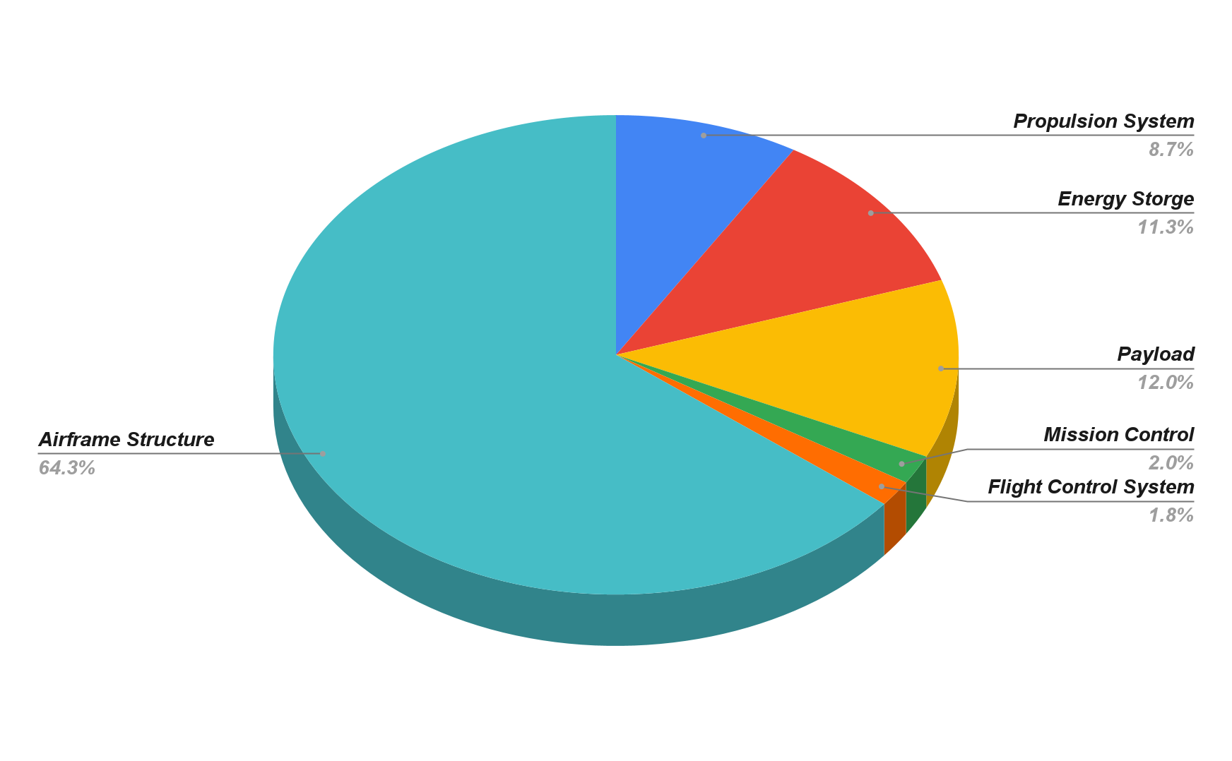
Figure B2: Aircraft component weight percentages
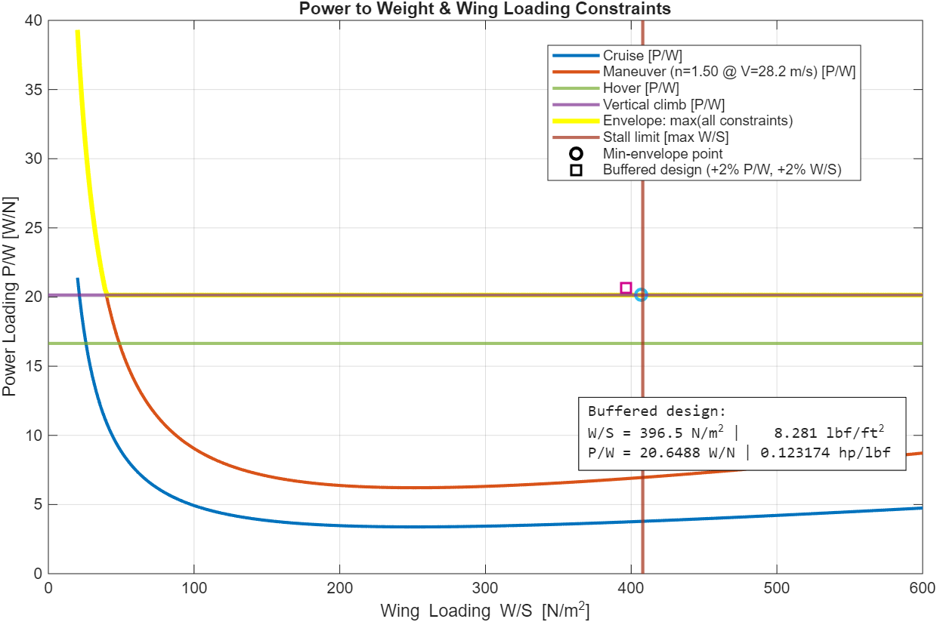
Figure B3: Power to Weight (P/W) versus Wing Loading (W/S) constraints, the pink square shows the most efficient Loading choice with a margin of safety of +2 %

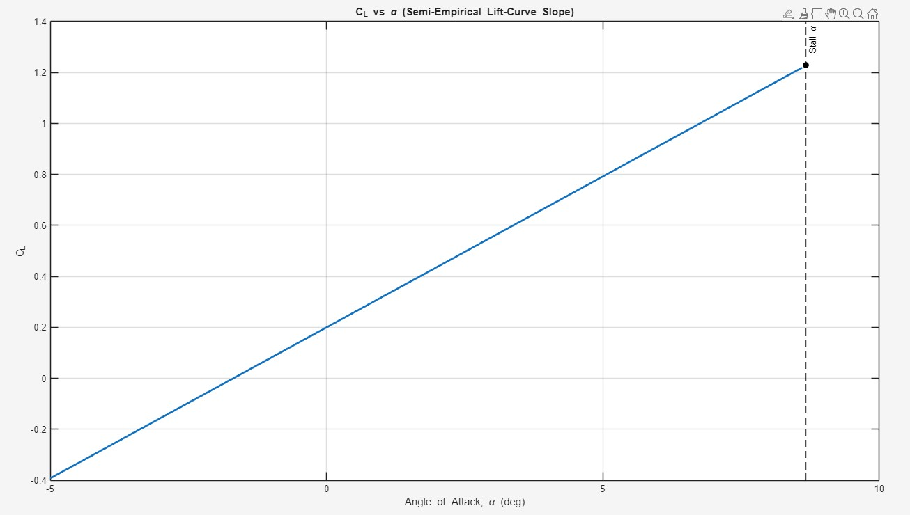
Figure B4: Lift Coefficient (CL) versus angle of attack (alpha) [degrees]
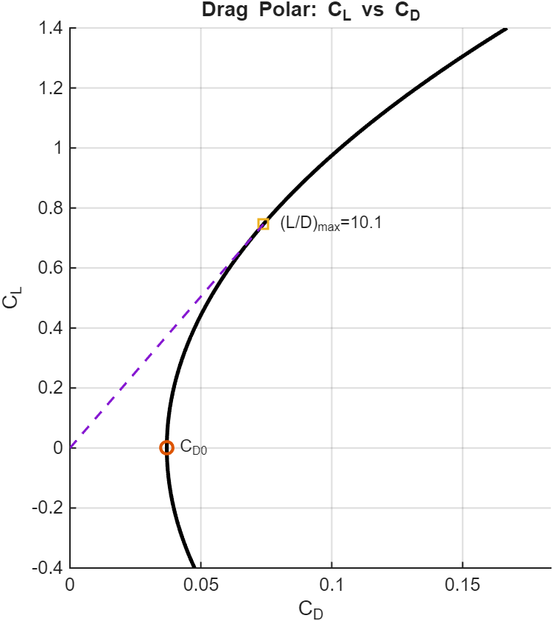
Figure B5: Lift Coefficient (C_{L}) versus Drag Coefficient (C_{D})

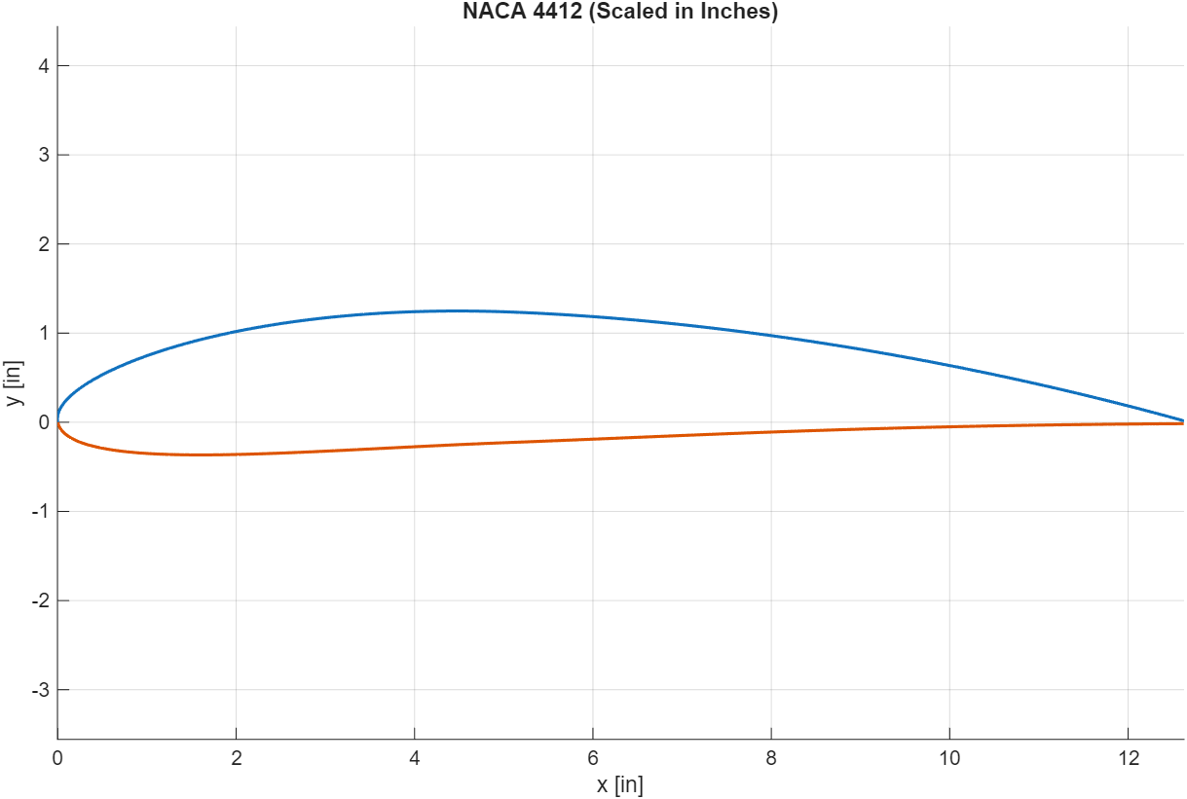
Figure B6: Plotted NACA 4412 cambered airfoil scaled to inches

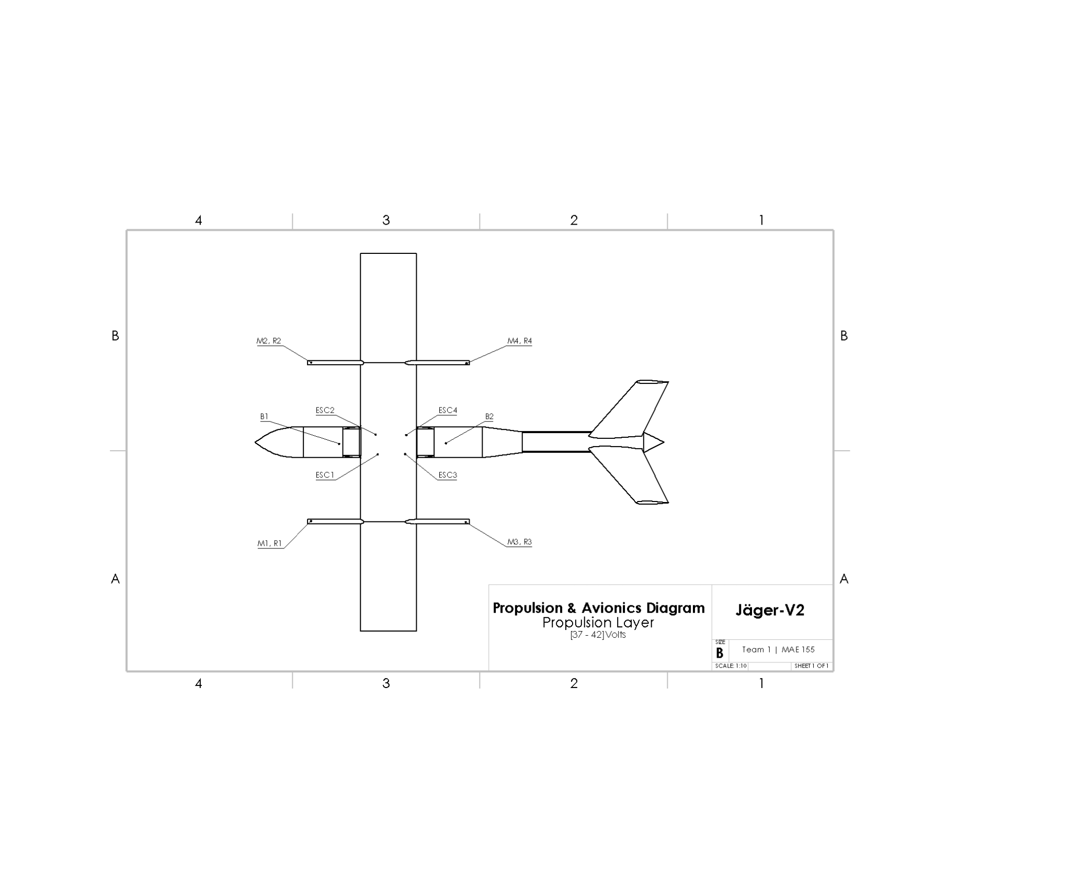
Figure B7: Propulsion Diagram, ref “Table C1”
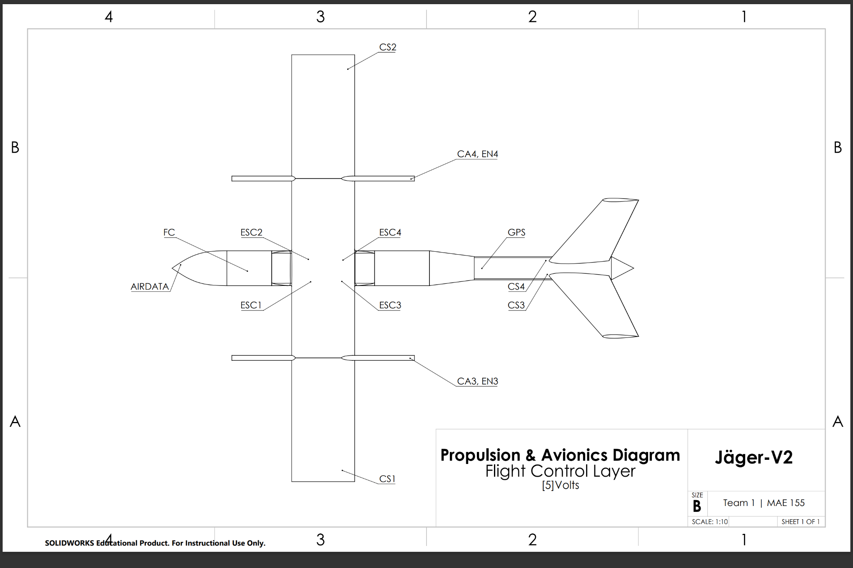

Figure B8: Flight control, ref “Table C1”

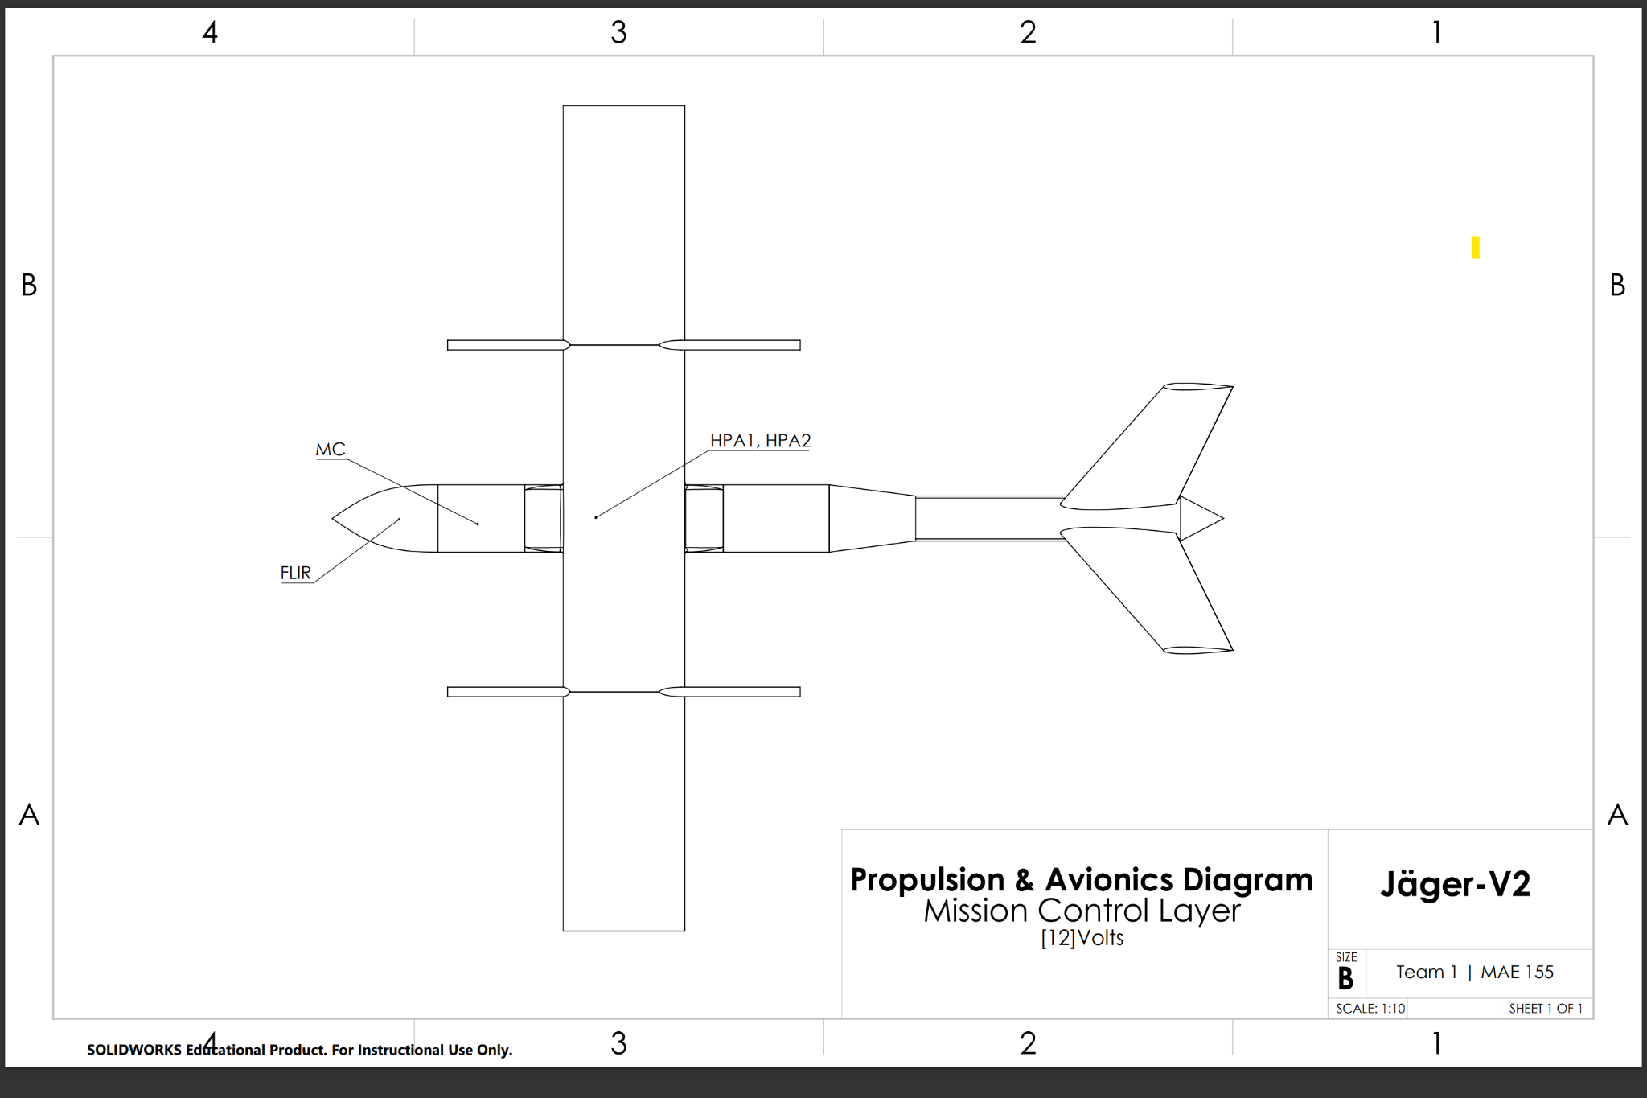
Figure B9: Mission control, ref “Table C1”
Appendix C: Tables

Item | Description | Weight (lbs) | Position from nose (x) (in)
M1 | Motor for FWD LH Rotor | 0.85539358 | 4.37
M2 | Motor for FWD RH Rotor | 0.85539358 | 4.37
M3 | Motor for AFT LH Rotor | 0.85539358 | 41
M4 | Motor for AFT RH Rotor | 0.85539358 | 41
R1 | FWD LH Rotor | 0.09479877 | 4.37
R2 | FWD RH Rotor | 0.09479877 | 4.37
R3 | AFT LH Rotor | 0.09479877 | 41
R4 | AFT RH Rotor | 0.09479877 | 41
ESC1 | Electronic Speed Controller 1: Sends Power to M1 | 0.24250849 | 27
ESC2 | Electronic Speed Controller 2: Sends Power to M2 | 0.24250849 | 27
ESC3 | Electronic Speed Controller 3: Sends Power to M3 | 0.24250849 | 30
ESC4 | Electronic Speed Controller 4: Sends Power to M4 | 0.24250849 | 30
B1 | Battery 1: S10 (37.0 / 42.0 Volts) | 3.1 | 10
B2 | Battery 2: S10 (37.0 / 42.0 Volts) | 3.1 | 50
HP1 | Hard point 1: FWD ordinance | 3.30693393 | 23.70275591
HP2 | Hard point 2: AFT ordinance | 3.30693393 | 30.20275591
FLIR T | Forward looking Infrared turret | 0.25794085 | 4.615
FC | Flight controller | 0.0838 | 10
MC | Mission Controller | 0.1014 | 11
HPA1 | Hard Point Actuator Solenoid 1 | 0.353 | 30
HPA2 | Hard Point Actuator Solenoid 2 | 0.353 | 30
AIRDATA | Air speed indicator | 0.0077 | 1
CS1 | LH Aileron Control Servo | 0.1433 | 33
CS2 | RH Aileron Control Servo | 0.1433 | 33
CS3 | LH V-tail Control Servo | 0.1433 | 87
CS4 | RH V-tail Control Servo | 0.1433 | 87
EN3 | LH AFT Motor Conversion Encoder | 0.0066 | 41
EN4 | RH AFT Motor Conversion Encoder | 0.0066 | 41
CA3 | LH AFT Motor Conversion Servo | 0.1433 | 41
CA4 | LR AFT Motor Conversion Servo | 0.1433 | 41
GPS | GPS | 0.0154 | 61
AF | Air Frame Structure Allocation by Weight | 35.37008793 | N/A
Table C1: Weights and Balance Values

Reference relative to nose (x₀) in | (in)
Center of Gravity from nose | 28.02
Quarter Chord from nose | 27
MAC | 12.63
MAC Leading edge | 24
Neutral Point | 30.12
References as % of MAC | (%)
CG | 31.86
Neutral Point (NP) | 48.47
Table C2: MAC-Based Stability References

Mass Fractions (%)
W_{b}/W₀ | 9.8
W_{p}/W₀ | 12.0
W_{e}/W₀ | 76.3
Undefined | 1.9
Table C3: Initial Sizing Mass Fractions of battery (W_{b}), payload (W_{p}), and empty (W_{e})

Computed Requirements
Power Required per Motor | 1.6936 hp
Thrust Required per Motor | 15.125 lbf
KV required | 192.6 RPM/V
Rotors: VZ22*7.4 by T-Motor
Diameter | 22 in
Pitch | 7.4 in
Power output | 1.72 hp @ 5700 RPM
Thrust output | 15.10 lbf @ 1.22 hp
Motor: VL6013 by T-Motor
Continuous Power Output (180s) | 17.43 hp1
KV | 210 PRM/V
Table C4: Propulsion System

Copy & Paste

Figure 3: Power to Weight (P/W) versus Wing Loading (W/S) constraints, the pink square shows the most efficient Loading choice with a margin of safety of +2 %


Figure 4: Lift Coefficient (CL) versus angle of attack (alpha) [degrees]

Figure 5: Propulsion Diagram, ref “Table C1”

Parameter | Symbol | Value | Units
Wing Area | S | 6.64 | ft²
Wingspan | b | 6.31 | ft
Aspect Ratio | AR | 6 | —
V-tail Area | S_{tail} | 0.1178 | ft²
Wing Loading | W/S | 8.28 | lb/ft²
Chord | c | 1.052 | ft
Table 2: Wing Geometry
Table 1: Aerodynamic Coefficients
Parameter | Symbol | Value
Max Lift Coefficient | C_{Lmax} | 1.60
Lift Coefficient at no angle of attack | C_{L0} | 0.40
Lift Curve Slope | C_{La} | 6.32
Induced Drag | C_{Di,cruise} | 0.0996
Parasitic Drag | C_{D0} | 0.0263

